Child-Friendly Anti Bullying Policy

What is bullying?

Bullying is deliberately hurtful behaviour, repeated over a period of time. Bullying can be:

- Physical – e.g. Hitting, kicking, pushing, biting, theft;
- Verbal – e.g. Teasing, name calling and jokes
- Indirect – e.g. Spreading rumours, deliberately leaving a child out of group play activities or not talking to them on a consistent basis
- Cyber – e.g. Hurtful messages online or by text

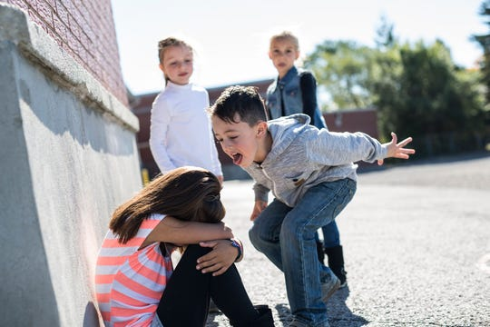

What to do if you see or experience bullying?

If someone bullies you or you see bullying behaviour by other children, you must:

Tell an adult

Adults will listen to you and they will stop this from happening.

Adults will help the victim and will also help the bully as there is usually a reason why the bully behaves in this way.

If you see younger children bullying others, you might try to stop it yourself but please tell an adult as well.

If you prefer, you can write a note and put it in your Class’s Communication Box.

By tackling bullying, we can help to make School a safe and happy place for everyone.

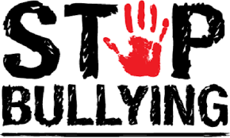

October 2021

