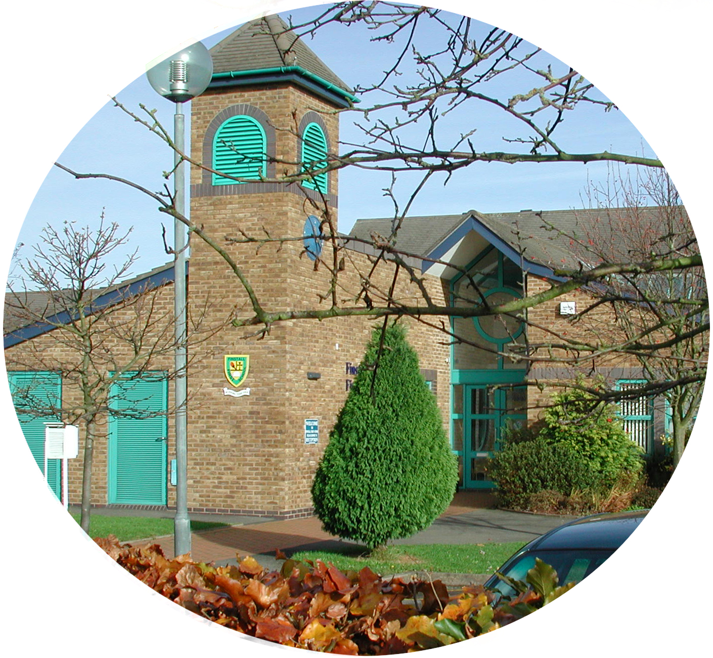
FINSTALL FIRST SCHOOL

Carnforth Road
BROMSGROVE
Worcestershire
B60 2HS
Tel: 01527 872938
Fax: 01527 836448
E-mail office@finstall.worcs.sch.uk
Web Site http://moodle.finstall.worcs.sch.uk/
HEADTEACHER: Mr Stuart Evans
We care, we share, we learn and achieve

Induction Day

Dear Parents

We would like to invite your child to spend an afternoon in Reception on Monday 16th July. Please come to the Reception gate at 1.00pm. The children will have the opportunity to spend time with their teacher, teaching assistant and the other children in their class. Please can they bring a healthy fruit or vegetable snack for break time. Please dress your child in clothes they would wear for pre-school. At 3.15pm, you can collect your child by coming to the Reception gate.

Yours sincerely

Reception Team

