Welcome to
Finstall First School
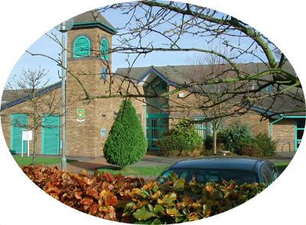

We are looking forward to seeing you at
Finstall First School
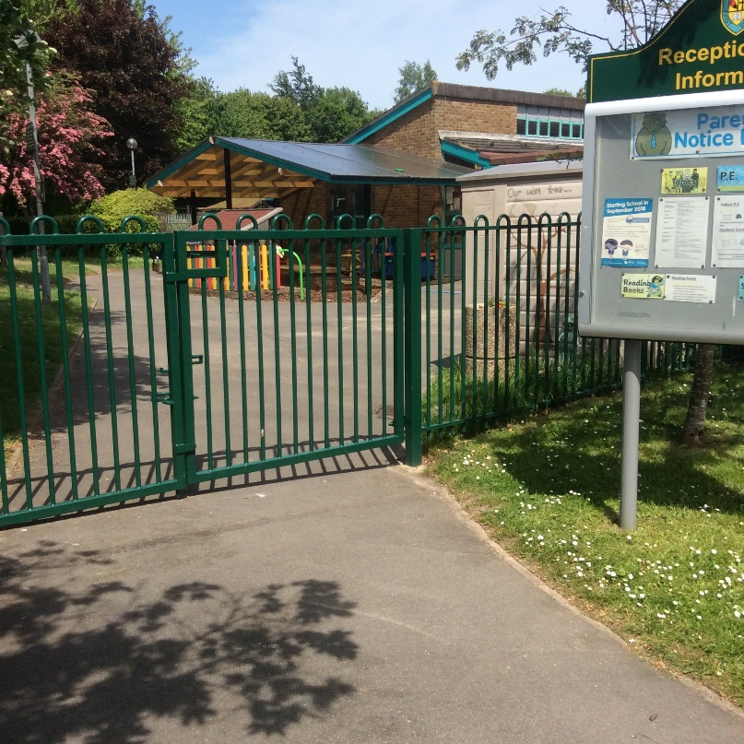

This is our Reception gate. You will use this entrance when you come in to Reception in the mornings. An adult will be waiting for you at the Reception door. This playground is where you will be collected at the end of the day.
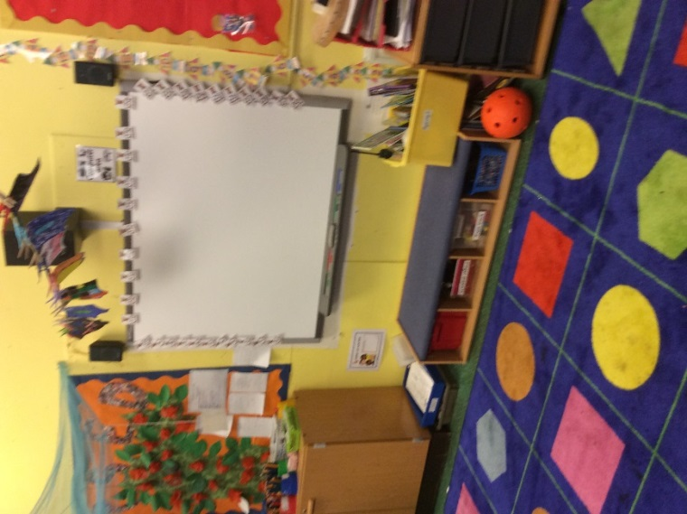
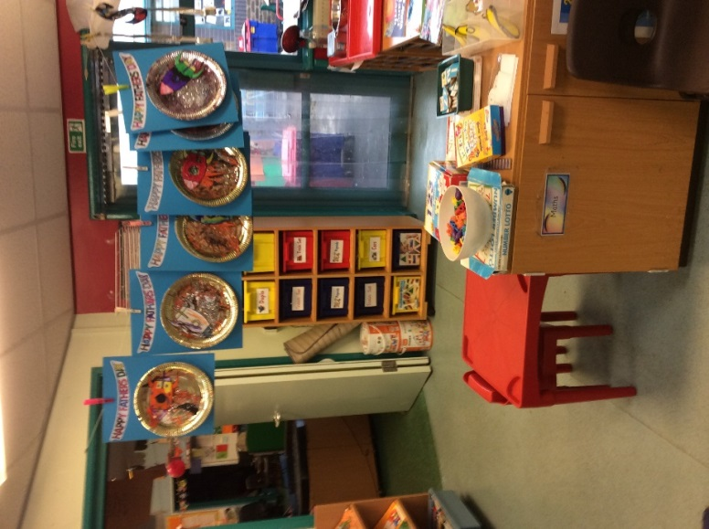

This is Rabbits This is
classroom. Hedgehogs classroom.

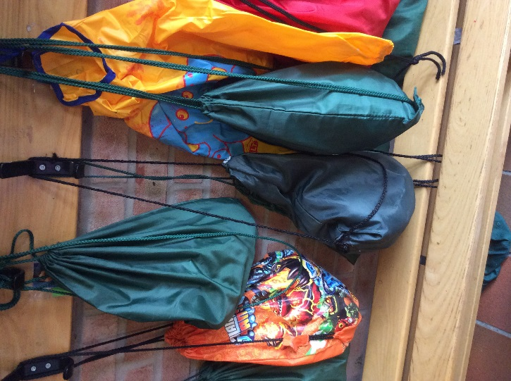
We each have a named peg in the cloakroom.

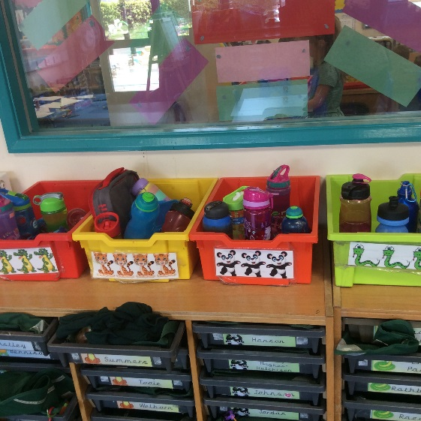
We put our drinks bottles in the boxes by our trays.

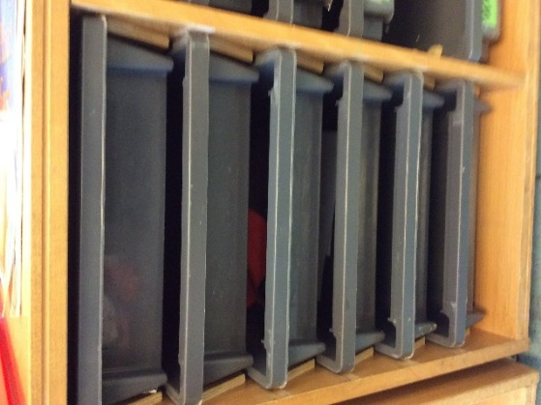
We each have our own drawer where we keep our book bag. Any important letters are sent home via email and paper copies are sometimes put in your book bag too.
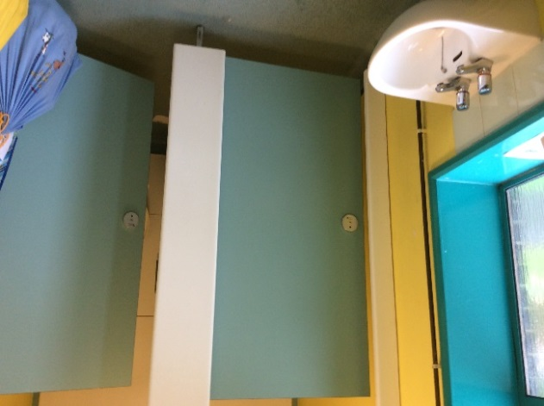
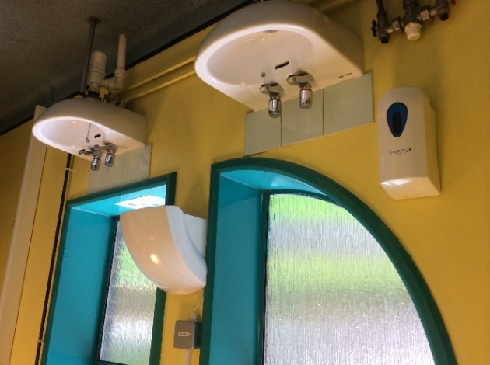
We must remember to wash our hands after using the toilet and turn off the taps.

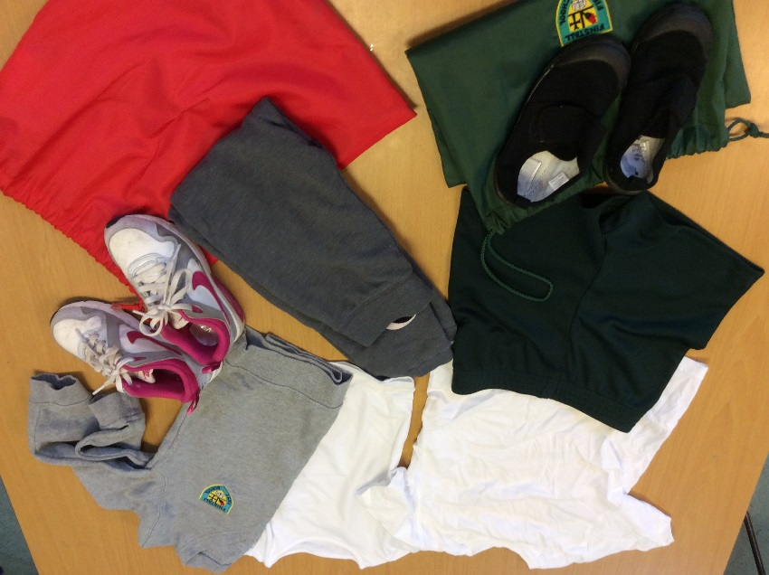
PE kit is kept in our PE bag on our peg in the cloakroom. Games kit is kept in a separate bag. Please make sure everything is labelled.

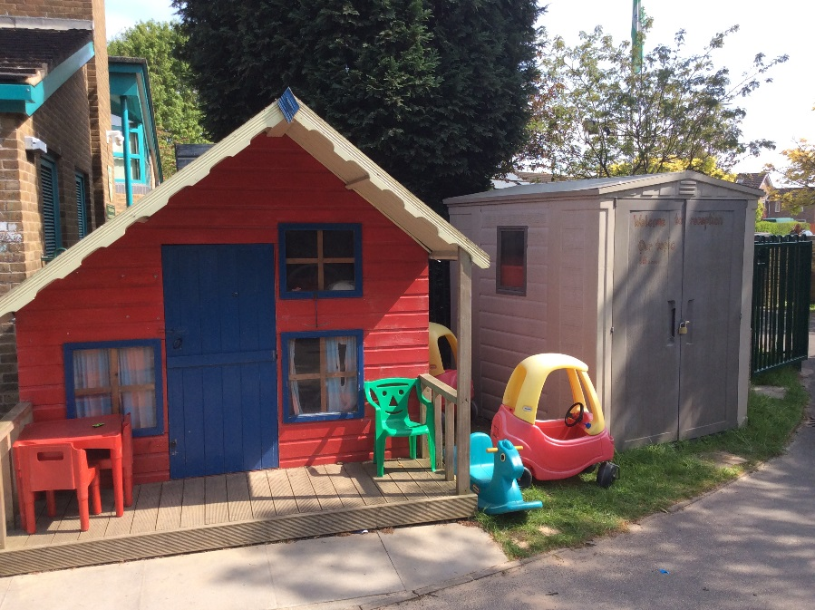
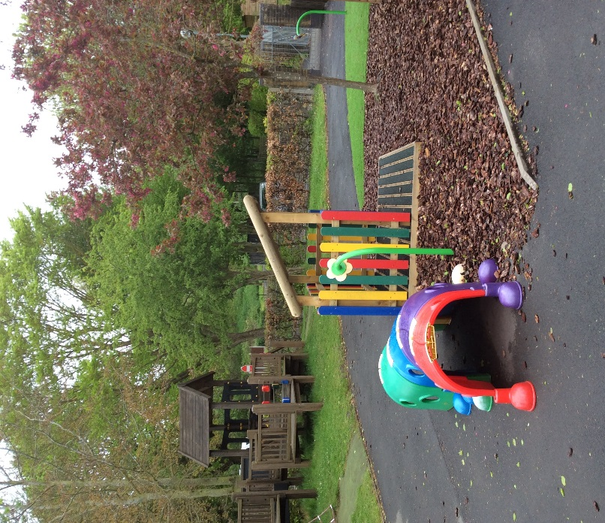
This is our outdoor area.

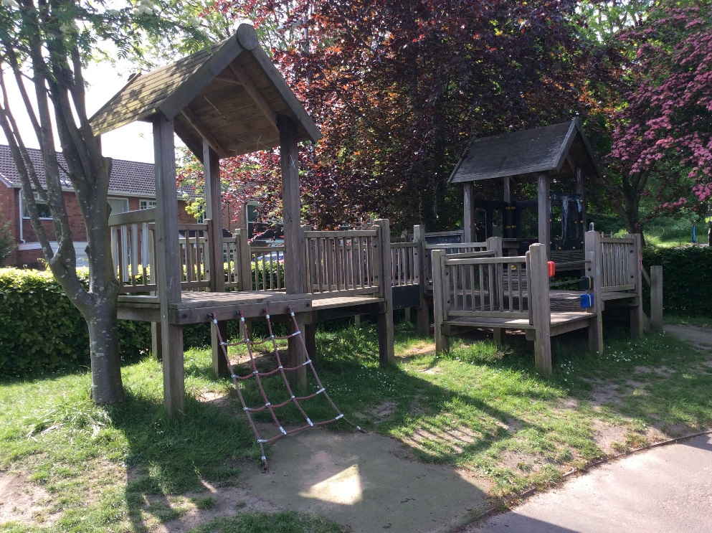
This is our Hill
Top Village.

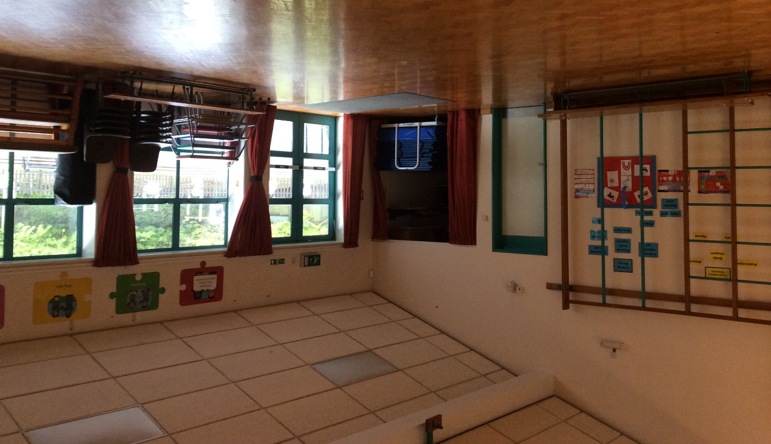
This is the main school hall, where we will have P.E lessons, eat our lunch and have assemblies.

At snack time in the morning we have milk, or a drink from our water bottles. We have a fruit snack brought from home or we choose a snack provided by school.
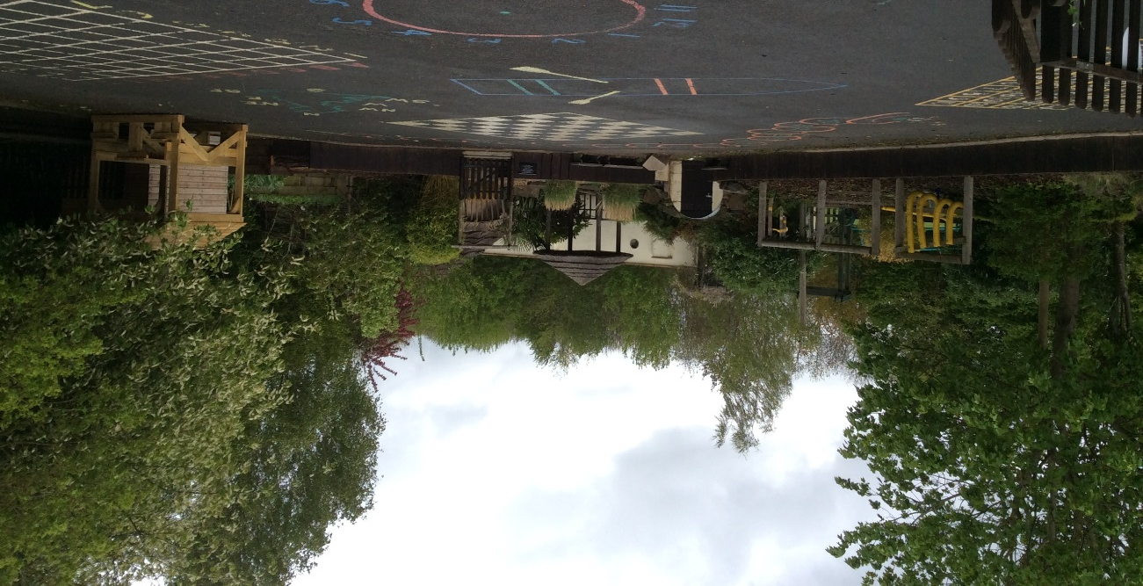
This is the playground where we go out to play at lunch time.

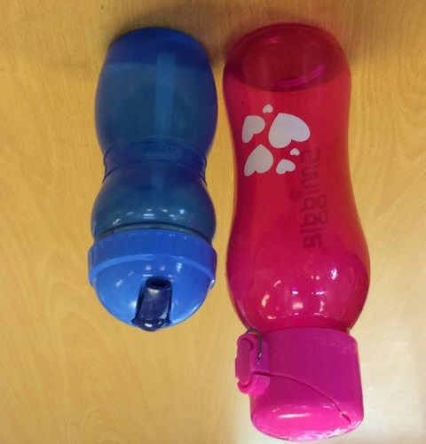
You bring a named drinks bottle to school, so that you can have a drink when you get thirsty.

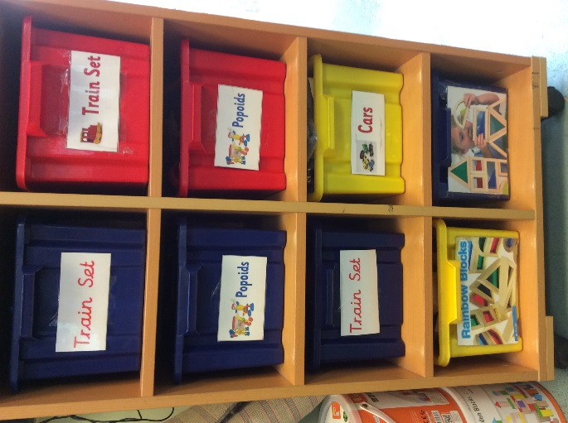
These are some of the toys and activities we use to help us with our learning.

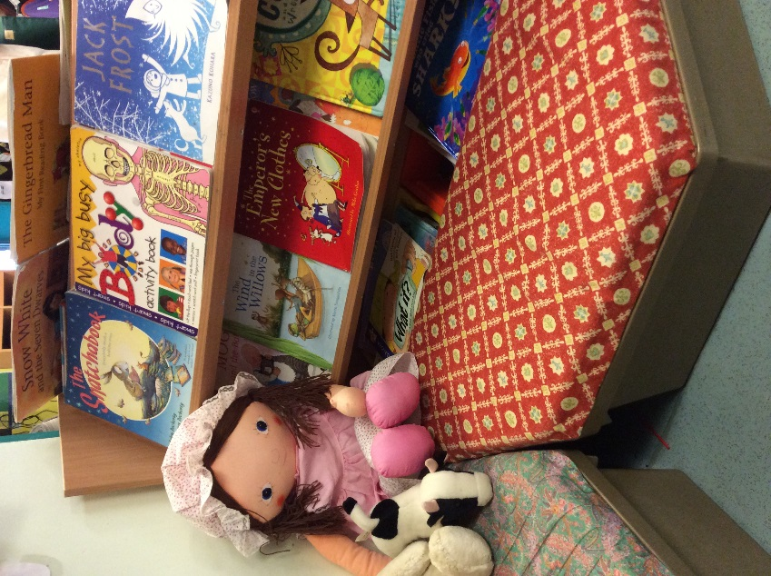

We have a Book Corner.
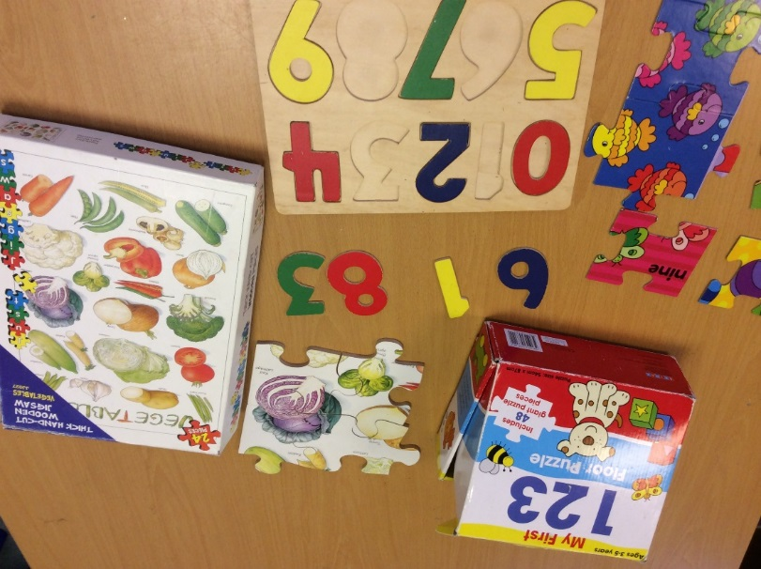
We play with puzzles.

This is our Role Play Area.
