FINSTALL FIRST SCHOOL

ATTENDANCE POLICY

PERSON RESPONSIBLE: Head Teacher

INTRODUCTION

At Finstall First School, we recognise that regular attendance is extremely important. Pupils need to attend regularly if they are to get the most from the educational opportunities provided within our school and achieve maximum progress. Absence can lead to educational disadvantage for a pupil and even place them at risk. Truancy all too frequently results in pupils being drawn into patterns of anti-social or criminal behaviour and puts them at risk of harm and abuse.

In order to maximise rates of attendance, which is one of our underlying aims, we must, as a staff, remain vigilant and be prepared to react positively and without delay. The issues are complex, since pupils may be failing to attend regularly for a variety of reasons, some of which may be outside the school’s immediate control, but nevertheless we must actively pursue the goal of regular attendance. To this end, we will investigate absences rigorously and will applaud and commend regular attendance.

We will ensure, through the School Brochure and other communications, that parents are made aware of the school’s policy on attendance; namely that individual absences will be carefully investigated and that unjustified absence will not be tolerated.

The law is quite definite that it is the legal responsibility of a parent to ensure that children of compulsory School age receive efficient full-time education whether by regular School attendance or otherwise. They are responsible for ensuring that children attend School and stay at School. Furthermore, parents are not only under a legal duty to send their children to School regularly, but also to ensure that they arrive on time, properly dressed and in a condition to learn. However, as with other aspects of education, regular attendance can only be implemented with the support of parents and School. The school and its parents must work together and maintain close links to achieve success in this and all other policies. However, whilst it is only right that we recognise the problems of individual pupils and families, the aim must always be to expect regular attendance.

The following guidelines are designed to aid staff in carrying out effective procedures concerned with attendance and to aid parents’ understanding of this process.

GUIDING PRINCIPLES

- Children cannot learn if they do not attend – school is a prerequisite to learning.
- Good attendance plays a vital role in communicating the school’s values and expectations.
- The school promotes a positive experience where there is an emphasis on developing good relationships with pupils and responding to their needs.
- We believe that it is the responsibility of staff and parents to promote good attendance.

AIMS

- To develop attitudes and behaviour that enable children to take an active and responsible role in the adult world.
- Recognition by staff, pupils, parents/carers of the importance of attendance to the overall achievement of pupils in the School environment.
- To promote a positive attitude towards attendance and good time keeping with pupils and parents/carers.
- To communicate clearly to parents/carers the school’s policy for attendance and good time keeping.
- To support pupils who are having difficulties attending and arriving on time.
- To create an expectation which gives attendance a high profile and ensures that absence is kept to a minimum.
- To ensure that non-attendance and poor punctuality are effectively monitored and absences are followed up (See Appendices B and C).

ROLES AND RESPONSBILITIES

- Class Teachers will maintain records of attendance for their class, following registration procedures.
- If a pupil is absent, without explanation, School staff will, wherever possible, contact the parents immediately. Details of calls made will be recorded on the proforma found in Appendix C.
- Any pupil giving cause for concern must be referred to the Head Teacher to check trends in absence.
- The Head Teacher will monitor registers on a regular basis. Problems are to be followed up by the Head Teacher or the Class Teacher, if deemed more appropriate.
- The Head Teacher is responsible for effective liaison with the School’s Attendance Officer.
- The Head Teacher will ensure that individual members of staff are following guidelines on completing registers.
- The Head Teacher must ensure that parents/carers are aware of the times for the beginning of each session and the procedures related to lateness and absence, school term dates and other additional days when a pupil is not expected to attend School.

PARENTS/CARERS

- Have legal duties to ensure their child attends School or receives an appropriate education if attendance is impossible.
- Will provide the Head Teacher/Class Teacher as soon as possible with reasons for absence – preferably before 9.00am on the first day of absence - and keep the school informed if the absence will continue.
- Must inform the school when their child will be returning to school following a period of absence, preferably prior to their child’s return.
- Must complete a “Request for Leave during term time” form, available from the School Office, if they wish to take their child out of School during term time (See below).

SAFEGUARDING AND CHILDREN MISSING EDUCATION

A child going missing from education is a potential indicator of abuse or neglect. School staff should follow the school’s procedures for dealing with children that go missing from education, particularly on repeat occasions, to help identify the risk of abuse and neglect, including sexual exploitation, and to help prevent the risks of their going missing in future.

Schools are required to make the local authority aware of every registered pupil who fails to attend school regularly and any children who have been absent from school, where the absence has been treated as unauthorised for a continuous period of not less than 10 school days Education (Pupil Registration) (England) Regulations 2006 regulation 12.

The Local Authority provides further information and guidance on children missing from education, emphasising the link between poor school attendance and safeguarding concerns (See Appendix G).
The Attendance Lead and the Designated Safeguarding Lead should work closely to manage risks and to ensure appropriate multi-agency engagement, where necessary, so that children and young people receive the appropriate level of early help or statutory intervention to ensure they attend school regularly.

THE EDUCATION WELFARE SERVICE / SCHOOL ATTENDANCE OFFICER

This is a vital link in the chain of home/school liaison so essential in the maintenance of high levels of attendance. The Head Teacher will, at all times, work closely with the School Attendance Officer, who will be advised and consulted regarding attendance and welfare problems. The support of the School Attendance Officer will be sought when we are unable to establish a reason for a pupil’s absence or in the case of an emerging pattern of absence. The School Attendance Officer will inform the Head Teacher of the results of a home visit and they will work closely together in their attempt to affect a satisfactory resolution to the absence problem.

The School Attendance Officer will be contacted by the Head Teacher to:-

- Investigate causes of absenteeism;
- Develop links between home and school;
- Provide support to families by home visits when needed;
- Make referrals to the Education Investigation Service in cases of unauthorised absence;
- Attend meetings when necessary.

REGISTRATION PROCEDURES

The register is a document required by law and we must recognise that we are under a statutory obligation to mark it with care and accuracy. The Education Regulations 1991 relating to Pupil’s Attendance Records require that registers must show whether an absence of a pupil of compulsory school age is authorised or unauthorised. Registers will be consulted together with the authorisation of absences in the case of legal proceedings.

Registers are kept electronically through SIMS (Schools’ Information Management System), which is hosted and stored off-site by IBS Schools. Class Teachers access this through their School Laptops through our E-School website, which transfers the data to SIMS. The School Secretary checks the registers against her own records of phone calls and messages following their completion.

Registers will be called twice daily and recorded electronically at the commencement of morning and afternoon school.

- The correct codes to authorise absence must be used when completing registers. These are displayed on the electronic system used.
- If a pupil is late to registration but arrives before the register officially closes (at 9.20am), count as present. In such cases, amendments will be made by the School Secretary as the child arrives via the secure door next to the School Office.
- Notes and messages regarding absences are confidential and remain in the pupils’ communication books or in the specified class plastic wallet until they are shredded.

AUTHORISED AND UNAUTHORISED ABSENCE

Only the School, within the context of the law, can approve absence. The fact that a note has been offered by the parent/carer does not mean that the School will authorise it if the School does not accept the explanation offered as a valid reason.

Examples of unauthorised absence may include minding the house (unless in exceptional circumstances), family holidays (See below), shopping, birthdays.

Authorisation for absence cannot be given retrospectively.

REQUESTING LEAVE DURING TERM TIME

Should a parent wish to request leave during term time, they should first complete the form “Request for Leave during Term Time” (See Appendix D). This is available on the School’s Website or from the School Office.

Parents will then receive, from the School, either:

- A letter that explains that the request has not been approved and a reminder that, if taken, this leave will be recorded as unauthorised and may be subject to a Penalty Notice fine (See Appendix E)
Or

- A letter that explains that the request has been approved because there are exceptional circumstances (See Appendix F).

Examples of such letters are also available on our Website. Please note that such letters will be sent irrespective of the length of the requested absence.

Parents should be mindful of the fact that, as a result of amendments to the Education Regulations 2006, Head Teachers may not grant any leave of absence unless there are exceptional circumstances. As a general guide, Head Teachers have been informed that, although each application should be considered on its individual merits, any activity, holiday or event that can be arranged during the annual 13-week holiday time should not be authorised during the School term. Should Head Teachers require it, further advice is available from the Education Investigation Service.

Once the Head Teacher becomes aware of the fact that an unauthorised absence has been taken, whether parents have informed the school or not, he or she must inform the Education Investigation Service, who will decide whether to a apply a Penalty Notice Fine.

Although the Head Teacher may sympathise with parents who, for different circumstances, feel they need to take holidays during term time, it has been made very clear that the Leadership and Management of Schools will be subject to severe criticism if Head Teachers do not follow the processes described above.

Should parents decide to take unauthorised holiday absence during term time, please do not ask your child to deceive their teachers and friends as we would still prefer that the children have the opportunity to share their experiences. More importantly, asking children to deceive adults is not a good message to be giving them.

Further information about the processes outlined above can be found in the following documents from Worcestershire County Council’s Education Investigation Service –

“Education Penalty Notice - Code of Conduct”
“Leave in Term Time – Absence Policy”

EXCLUSIONS (DFE Guidance 1994)

- Where a pupil has been temporarily excluded treat as authorised absence.

- Permanent exclusion – treat as authorised absence until confirmed, then remove from the School roll.

REWARDING ATTENDANCE

Children are rewarded with a certificate for 100% attendance at the end of each term and at the end of a school year.

PUNCTUALITY

Children should arrive at school at any time between 8.50am and 9.00am.
The children’s entrances are locked behind each class as they enter school so any children who arrive after this time have to enter the school via the office entrance, which is securely controlled by the School Secretary.
Late arrivals create disruption to assemblies / lessons, which is not fair on those children who are late or the children who have arrived on time.

We accept that anybody can be late for a variety of different reasons and that these are occasionally outside of anybody’s control. In an attempt to reduce the number of late arrivals and thus the number of disturbances that children have to put up with at the start of the school day, we ask all parents of children who arrive after the children’s entrance are locked, to bring their children to the Office entrance and sign the “Late Book.” If a child is late more than three times in a half term, we will either make verbal contact with that child’s parents or, alternatively, send out a standard letter asking parents to ensure that their child arrives on time in future. Subsequent late arrivals within the same half term could result in us asking parents to provide us with a further explanation for their child’s late arrival.

ATTENDANCE TARGET

We have set ourselves the following challenging Attendance Target:

>96%

This policy was approved by the full governing body on 11th May 2020.

This policy will be reviewed in June 2023.

Governor responsible: Caroline Spencer

LIST OF APPENDICES

A Attendance codes, descriptions and meanings.

B Copy of letter sent to parents with regard to a pupil’s late arrival in school.

C Copy of proforma on which to record attempts by staff to contact parents / carers of absent children.

D “Request for Leave during Term Time” form

E Copy of letter sent to parents explaining that a request for leave during term time has not been agreed.

F Copy of letter sent to parents explaining that a request for leave during term time has been agreed.

G Children missing from Education Pathway

APPENDIX A

Attendance Codes

/ Present (am)
\ Present (pm)
B Educated off-site (not dual registered)
C Other authorised circumstances
D Dual registration
E Excluded
G Family Holiday (not agreed)
H Family Holiday (agreed)
I Illness
J Interview
L Late (before registration closes)
M Medical / dental appointment
N No reason yet provided
O Unauthorised absence
P Approved Sporting Activity
R Religious observance
S Study leave
T Traveller absence
U Late (after registration closes)
V Educational visit / trip
W Work experience
X Non-compulsory school age absence

Y – (For Office use only) – Unable to attend due to exceptional circumstances

APPENDIX B

Dear Parents,

In accordance with our Attendance Policy, I am writing to you because your child has been late for school on more than three occasions during this half term.
Late arrivals create disruption to assemblies and lessons, which begin immediately after the bell at 9.00am. This is not fair on those children who are late or the children who have arrived on time.

We accept that anybody can be late for a variety of different reasons and that these are occasionally outside of anybody’s control. However, following four late arrivals during this half term, we politely request that you ensure that arrives on time in future.

If you are experiencing difficulties in getting to school on time, please let us know as we may be able to provide support for you or be able to put you in touch with someone else who could help you.

If you wish to discuss this matter further, please don’t hesitate to contact me to make an appointment.

Thank you in anticipation of your support.

Yours sincerely,
APPENDIX C

Absence Check

Name ____________________ Class _____ Date ____________

 | Details of Contact | Outcome | Time | Initials of adult responsible for contact
Contact 1:

Contact 2:

Contact 3:

Contact 4:

Contact 5:

Contact 6:

Result / Reason for absence:

Teachers’ signature: _______________________ Date: ________________
APPENDIX D
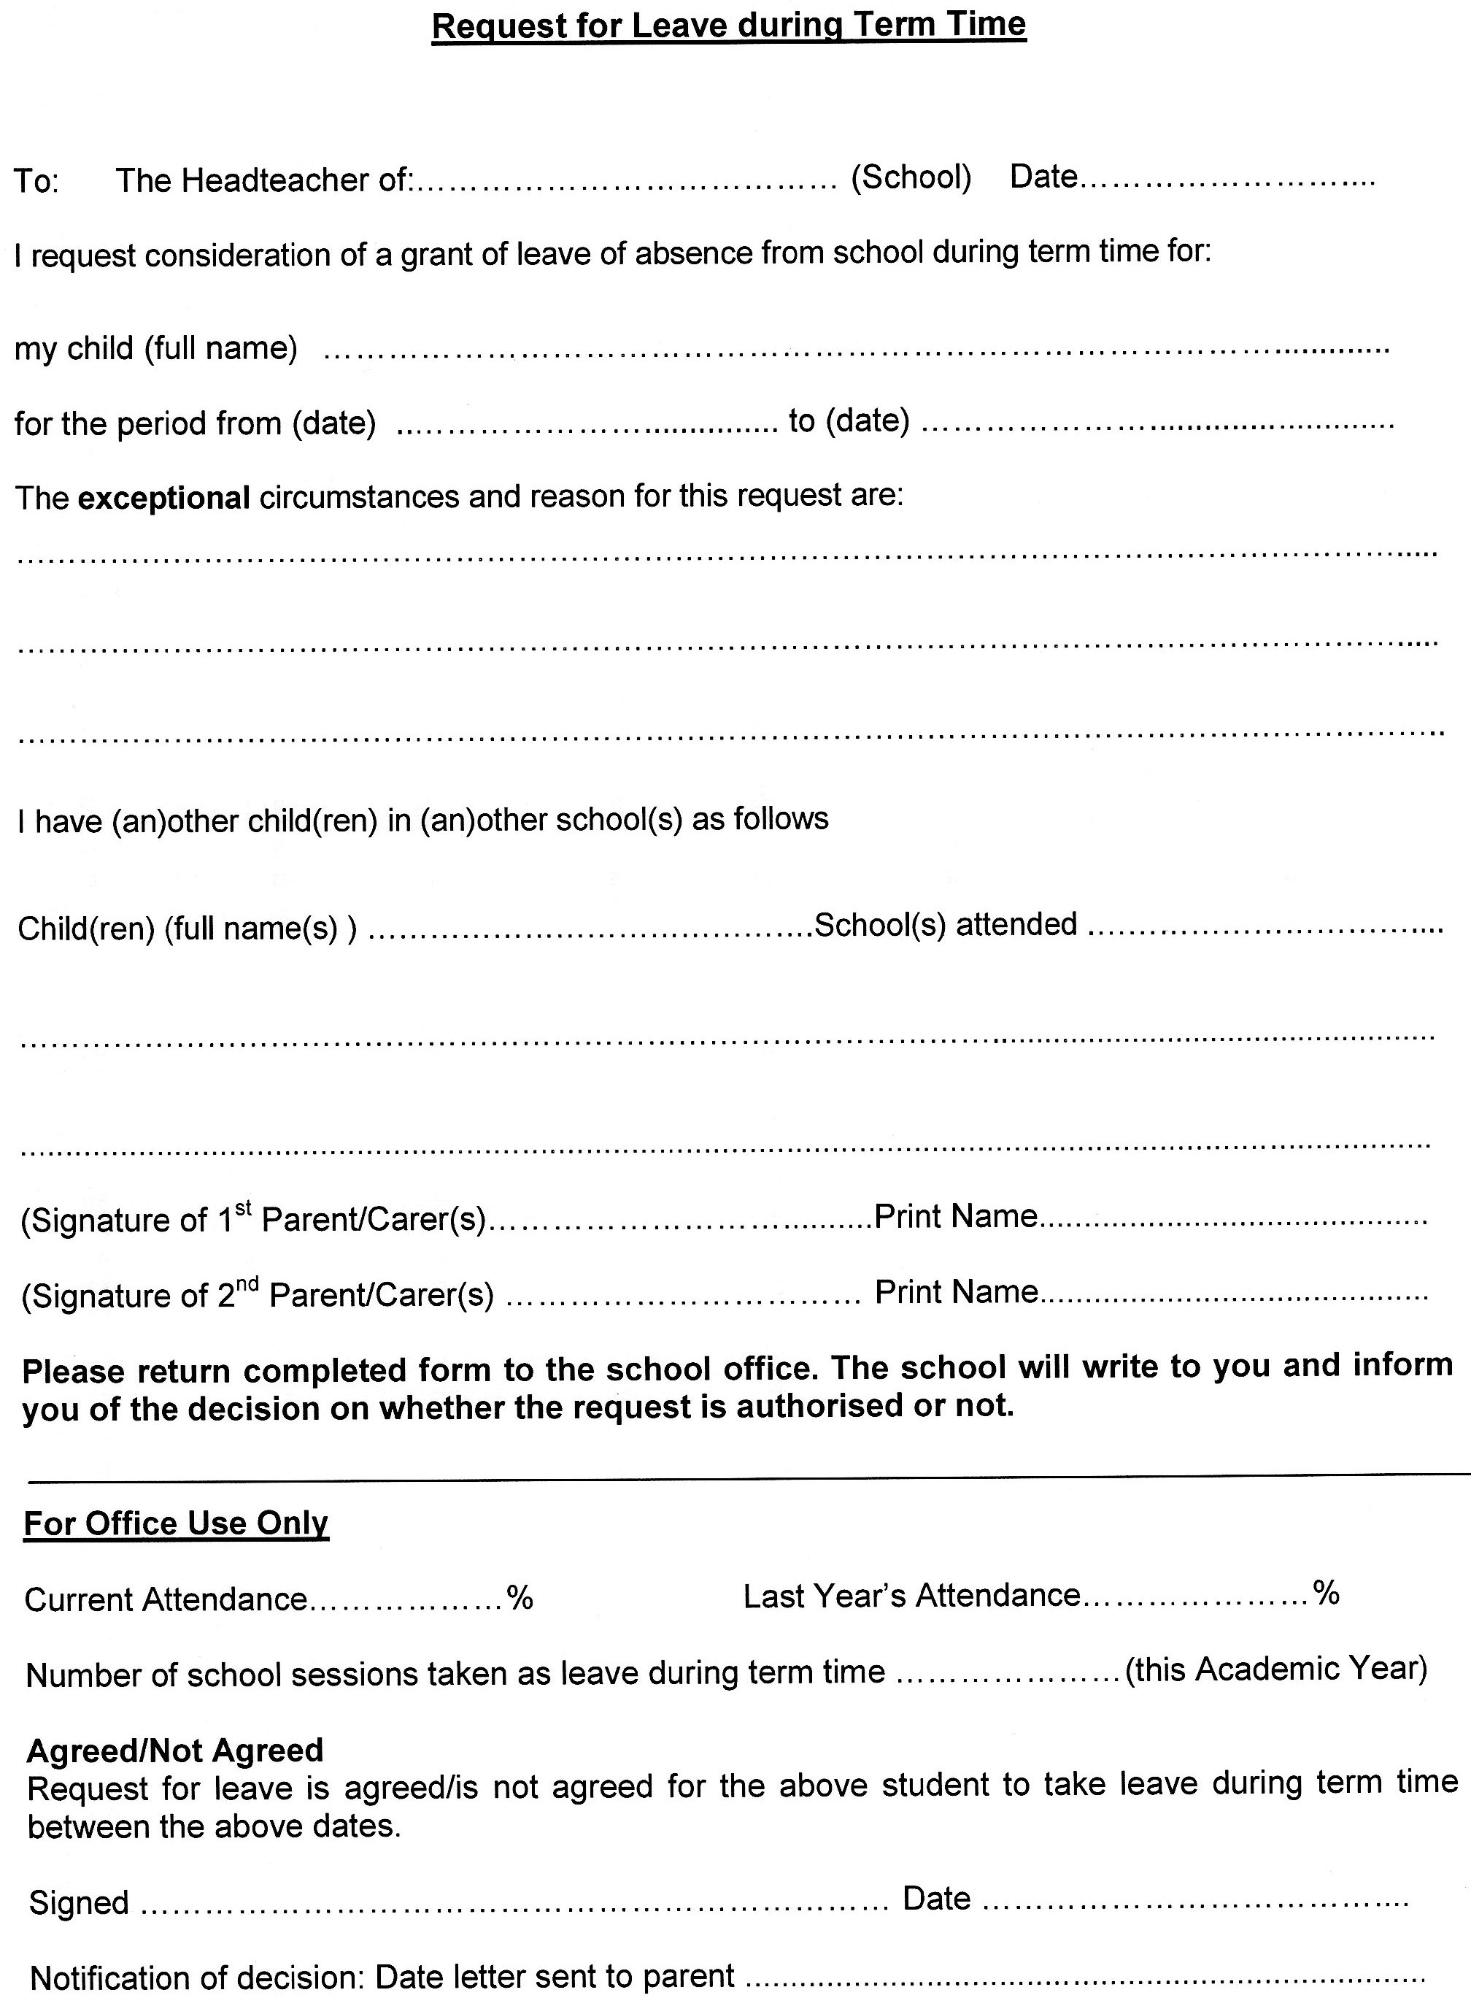

APPENDIX E

(Date)
(Parents’ name and address)

Dear (Parents’ name),

(Child’s name and date of birth)

Thank you for your request for leave during term time, dated (date), asking for permission for (pupil’s name) to be absent from school for (number of days) from (dates).
As you may be aware, the Government has renewed appeals to parents not to take their children out of school during term time. The Governors of the school support this and have decided that students will only be given permission to take leave in term time if there are exceptional circumstances. Having looked at your application, although understanding of your reasons, I do not feel that your request can be supported in this instance. Therefore, if the absence occurs, the dates will be unauthorised.

Our key priority is to ensure that (pupil’s name) is as successful as possible and is able to achieve (his/her) full potential. I would hope that, upon reflection you are able to support this decision in line with the Local Authority and Government policy that leave should be restricted to the 13 weeks school holidays except in exceptional circumstances.
However, should you still decide to take this leave, I am grateful that you have informed us so that your child will have the opportunity to share the experience with their friends and teachers.

As a school, we are asked to inform you that, in line with Worcestershire County Council Policy, following a period of unauthorised absence, a referral will be made to the Education Investigation Service which may result in the issue of a penalty notice fine of £60 payable per parent, per child, increasing to £120 each if not paid within 21 days. If this fine is not paid within 28 days this may lead to court proceedings.

We also request that you advise your children’s Class teachers of this absence if you have not already done so. Thank you for your understanding; I trust this letter explains the decision that has been made.

Yours sincerely

(Name)
(Job Title)

Appendix F

(Date)
(Parents’ name and address)

Dear (Parents’ name),

(Child’s name and date of birth)

Thank you for your request for leave during term time, dated (date), asking for permission for (pupil’s name) to be absent from school for (number of days), from (dates).
As you may be aware, the Government has renewed appeals to parents not to take their children out of school during term time. The Governors of the school support this and have decided that students will only be given permission to take holidays in term time if there are exceptional circumstances.
Having looked at your application, I feel that your request can be supported in this instance. Therefore, the absence to include the dates requested will be authorised.
Our key priority is to ensure that (pupil’s name) is as successful as possible and is able to achieve (his/her) full potential. I would hope that, in the future, you will continue to support the Local Authority and Government policy that leave should be restricted to the 13 weeks school holidays except in exceptional circumstances.
We also request that you advise your children’s Class teachers of this absence if you have not already done so.
I trust this letter explains the reason for the decision that has been made.

Yours sincerely

(Name)
(Job Title)

APPENDIX G

Children missing from education pathway

A child going missing from education is a potential indicator of abuse or neglect. Staff in education provision should follow the provision’s procedures for dealing with children that go missing from education, particularly on repeat occasions, to help identify the risk of abuse and neglect, including sexual exploitation, and to help prevent the risks of their going missing in the future.

All children, regardless of their circumstances, are entitled to a full time education which is suitable to their age, ability, aptitude and any special educational needs they may have. Central to raising standards in education and ensuring all pupils can fulfil their potential, pupils need to attend regularly. Missing out on lessons leaves children vulnerable to falling behind. Children with poor attendance tend to achieve less in both primary and secondary school.

Local authorities have a duty to establish, as far as it is possible to do so, the identity of children of compulsory school age who are missing in their area.

All education providers should:-

- Promote good attendance and reduce absence, including persistent absence
- Ensure every pupil has access to full-time education to which they are entitled
- Act early to address patterns of absence
- Ensure parents perform their legal duty by ensuring their children of compulsory school age who are registered at school attend regularly
- Ensure all pupils are punctual to school and lessons
- Ensure they liaise with the named social worker where Children’s Social Work are engaged with the child or family

School Requirements

The law requires schools to have an admission register and an attendance register. All pupils must be placed on both registers. Schools should use the national absence and attendance codes to record and monitor attendance and absence in a consistent way which complies with the regulations. They are also used for collection statistics through the School Census System. The codes are detailed in School Attendance (DfE, October 2014 - https://www.gov.uk/government/uploads/system/uploads/attachment_data/file/361008/Advice_on_school_attendance_sept_2014.pdf). Please note the requirements around the use of the L and U code (page 8), and requirements for recording attendance of Gypsy, Roma, Traveller pupils (page 11).

Schools should promote good school attendance and put in place appropriate safeguarding policies, procedures and responses for children who go missing from education, particularly on repeat occasions.
It is essential that staff are alert to signs to look out for, and the individual triggers to be aware of, when considering the risks of potential safeguarding concerns, such as travelling to conflict zones, FGM, CSE, forced marriage.

Involving other agencies and signposting:

All schools must inform the local authority of any pupil who fails to attend school regularly, or has been absent, without the school’s permission for a continuous period of 10 school days or more, at such intervals as are agreed between the school and the local authority.

Pupils at risk of harm/neglect - Children may be missing from education because they are suffering from abuse or neglect. Where this is suspected schools should follow child protection procedures. If there is reason to suspect that a crime has been committed or the child’s safety is at risk, the police should also be involved.

Families of members of the Armed Forces
Families of members of the Armed Forces are likely to move frequently – both in UK and overseas and often at short notice. Schools and local authorities should contact the MOD Children’s Education Advisory Service (CEAS) on 01980 618244 for advice on making arrangements to ensure continuity of education for those children when the family moves.

Children of Gypsy, Roma and Traveller (GRT) Families
Research has shown that many children from these families can become disengaged from education, particularly during the secondary school phase. Pupils are particularly vulnerable at transition from primary to secondary where a GRT pupil leaves school without identifying a new destination school. Schools should inform the CME team as soon as they become aware that a secondary school application will not be made for a GRT pupil. Although many are settled, some GRT families move regularly and their children can be at increased risk of missing education. Schools should work with families to minimise disruption to GRT pupils’ education, for example if the family need to travel in order to work, they should be supported to dual register with other schools.

Persistent Absence
The definition of persistently absent (PA) pupil as set by the DFE is a pupil with 10% or more absence (90% or less attendance). The table below, derived from the census guidance, gives an indication of the minimum number of sessions a pupil would miss by each half term to be classed as PA.

Half-term | 10%
Half-term 1 | 7 or more sessions
Half-term 1-2 (autumn term) | 14 or more sessions
Half-term 1-3 | 20 or more sessions
Half-term 1-4 (autumn term and spring term combined) | 25 or more sessions
Half-term 1-5 | 31 or more sessions
Half-term 1-6 (full academic year) | 38 or more sessions

Deletion of pupil from the admission register

Schools must notify the local authority when they remove a pupil from roll in line with the Removing Pupils from Roll: Guidance for Schools.

All schools must inform their local authority of any pupil who is going to be deleted from the admission register where they:

- have been taken out of school by their parents and are being educated outside the school system, eg: elective home education (EHE). Schools must not seek to persuade parents to educate their children at home as a way of avoiding excluding the pupil or because the pupil has a poor attendance record
- have ceased to attend school and no longer live within reasonable distance of the school at which they are registered
- have been certified by the school medical officer as unlikely to be in a fit state of health to attend school before ceasing to be of compulsory school age, and neither he/she nor his/her parent has indicated the intention to continue to attend school after ceasing to be of compulsory school age
- are in custody for a period of more than four months due to a final court order and the proprietor does not reasonably believe they will be returning to school at the end of that period
- have been permanently excluded

