Fabulously Fit at Finstall ‘Active Ideas’

Here at Finstall we try to encourage our pupils to be active outside of school. Below are some ideas on what children can do to encourage them to be active and healthy! Every half term, the children can complete a ‘Fabulously Fit at Finstall’ homework sheet for their chance to receive a certificate and possibly even a sporting prize!
Combine some of these activities to create 30 minutes of exercise fun!
Cycle on your bike for 15 minutes. | Go for a walk. | Play balloon tennis/volleyball for 10 minutes. | Walk to/from school. | Throw a Frisbee with someone for 15 minutes.
Hop on your right leg 10 times and then hop on your left leg 10 times. | Create your own obstacle course. | Play hoop target practise for 15 minutes. | Hold the plank for 10-30 seconds. | Dance to your favourite song.
Pass a ball (tennis, hockey football, rugby, basketball or netball etc. ) with someone for 15 minutes. | 20 high knees. | Ride on your roller skate/blades for 15 minutes. | Play tag with a friend/s for 10 minutes. | 20 heel kicks.
Skip for 10 minutes. (Count how many skips you could do in a row) | 15 minutes of active housework (Could be vacuuming/ sweeping etc.) | Play beat the goalie with someone for 15 minutes. | 10 push ups on knees. | Draw your own hopscotch with chalk and play it for 10 minutes.
20 squats. | 20 star jumps. | Go for a jog. | 20 sit ups or crunches. | Ride on your scooter for 15 minutes.
Practise handstands or cartwheels or forward rolls for 10 minutes. | Throw and catch a tennis ball on your own for 10 minutes. | Play on a skateboard for 15 minutes. | Go to the park and play for 15 minutes- 30 minutes. | Play ‘keepie-uppies’ with a ball.
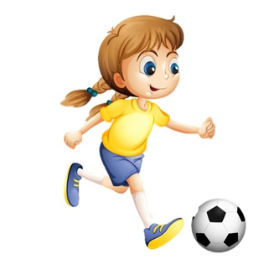
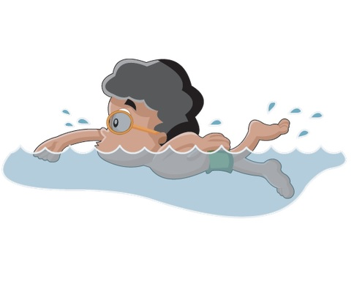

Ideas for Active days out:
- Go Ape
- Ice-skating
- Swimming
- Skate parks
- Local play parks
- Woodland trails
- Bowling
- Visit a maze

