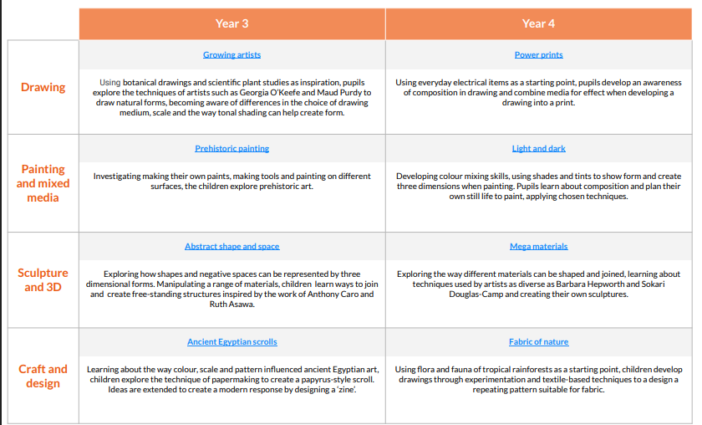Year 3 and 4 Curriculum overview for Art and Design