Welcome to

Finstall First School

[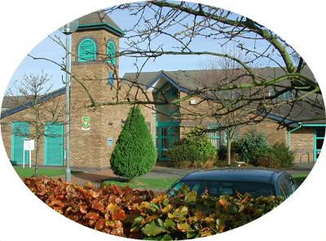](http://www.google.co.uk/url?sa=i&rct=j&q=&esrc=s&source=images&cd=&cad=rja&uact=8&ved=0CAcQjRw&url=http://www.bromsgroveonline.com/finstall-first-school.html&ei=agNJVcDFNYH5UK-GgfAB&bvm=bv.92291466,d.d24&psig=AFQjCNFROuRThlS6c7IiI-lfflOrnHkt4g&ust=1430934707680440)

Meet the Reception Team

|  |  |
| --- | --- |
| **Class Teachers** |  |
| Mrs Bennett  (Hedgehogs- Thursday and Friday)  (Rabbits - Monday) |  |
| Mrs Desmond  (Rabbits – Tuesday to Friday) |  |
| Mrs Law  (Hedgehogs – Monday - Wednesday) |  |
| **Teaching Assistants** |  |
| Miss Underwood  (Hedgehogs) |  |
| Mrs Simpson  (Rabbits) |  |

**School Entrance**

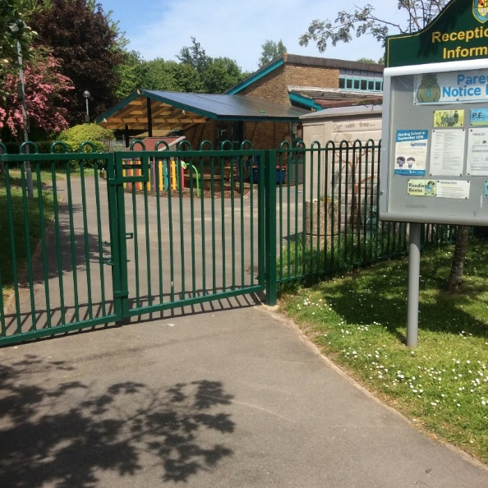

This is our Reception gate. You will use this entrance when you come into Reception in the mornings. An adult will be waiting for you at the Reception door. This is also where you will be collected at the end of the day.

**Our classes**

You will be in either Hedgehogs or Rabbits class.

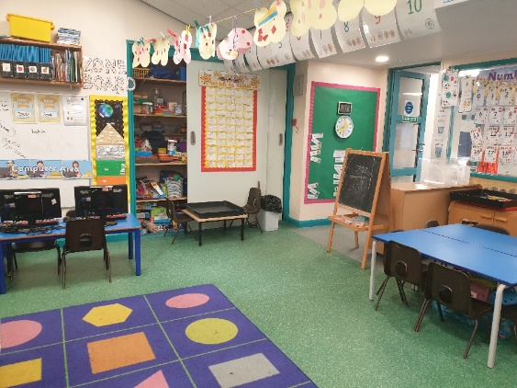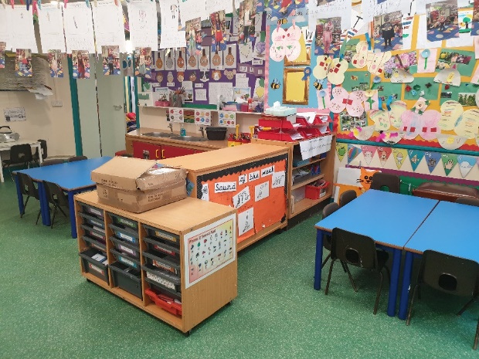

This is Rabbits classroom.

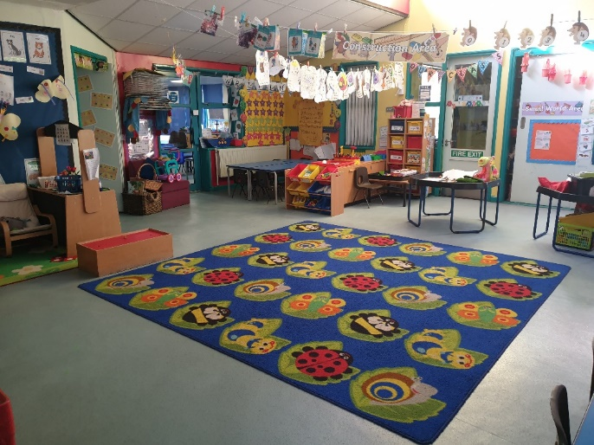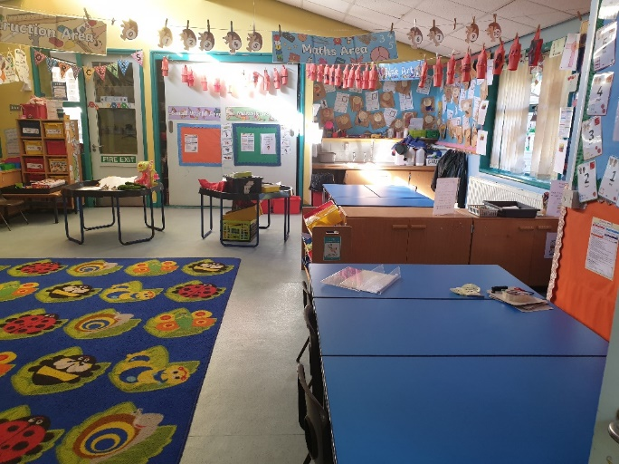

This is Hedgehogs Classroom

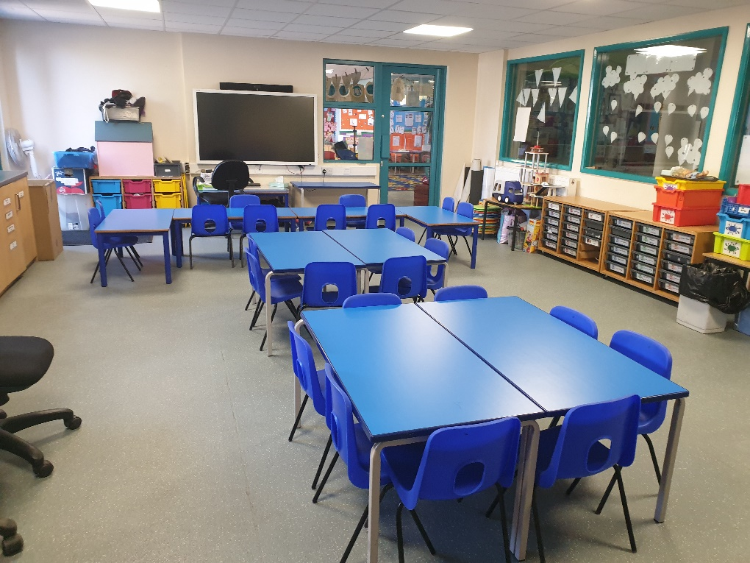

We also do lots of activities with small groups in our extra classroom.

**Where to put your belongings**

You will have a peg that has your name on. This is where you put your coat. Practise putting your coat on and trying to do the zip.

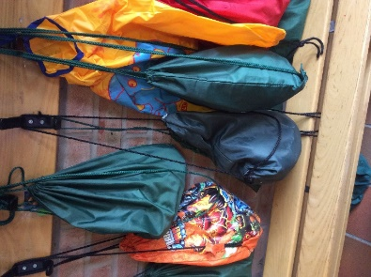

You will need a named drinks bottle so that you can have a drink when you get thirsty. You will have a box to put your water bottle in.

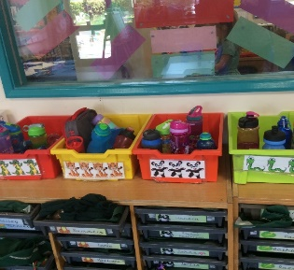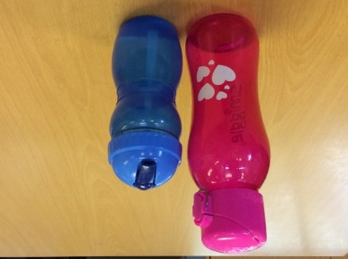

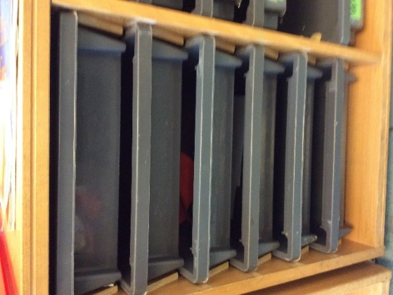You will have a drawer to put your book bag

and your healthy snack.

**Toilets**

You can go to the toilet whenever you need to. You must remember to wash your hands after using the toilet and turn off the taps.

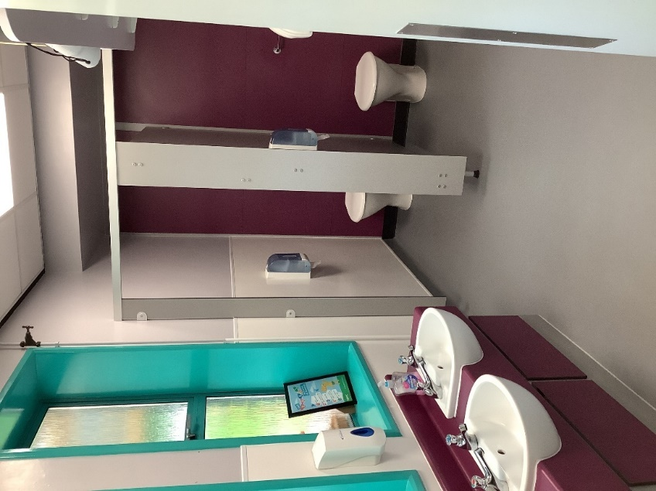

**P.E. Kit**

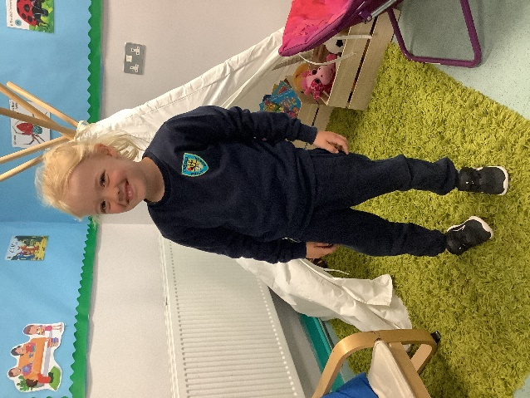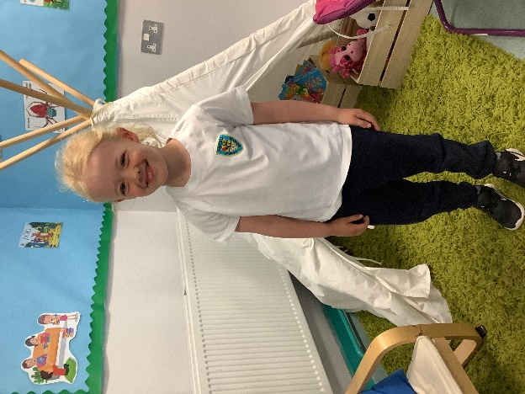

**Indoor P.E.**

**Rabbits PE day: Monday Hedgehogs PE day: Tuesday**

On P.E day, you will need to come to school wearing:

* Navy jogging trousers, white t-shirt, Navy jumper (Winter)
* Green shorts, White T-Shirt and trainers (Summer)

**Outdoor games**

We do outdoor games on a Thursday Afternoon. You will need to come to school wearing:

* White T-shirt, Navy jogging trousers, Navy jumper and trainers.

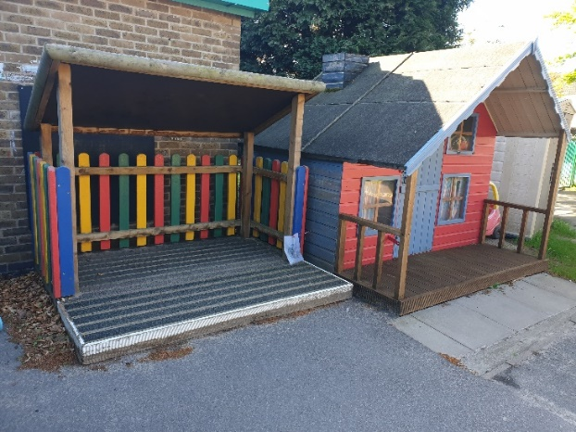**Outdoor area**

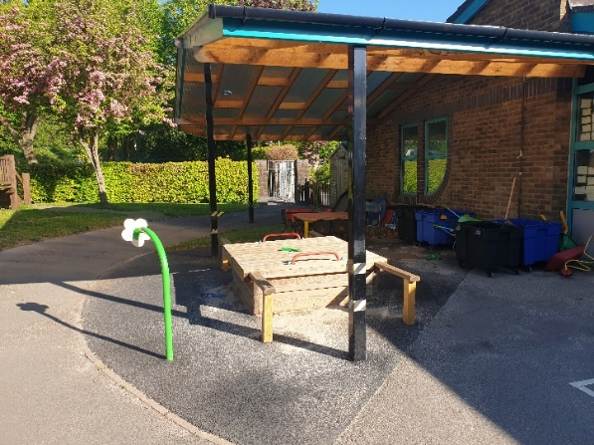This is our Outdoor area. You can choose to play outside with your friends.

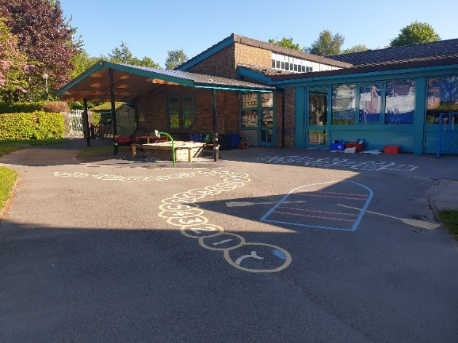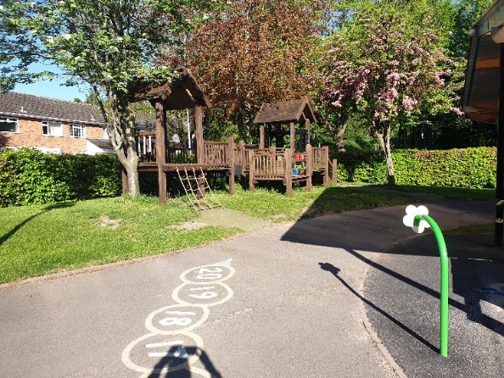

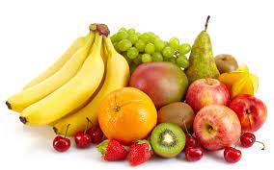**Milk and Snack**

During the morning, you will be able to choose when to have your healthy snack. You will get your snack from your book bag and sit at a snack table with your friends.

During the afternoon, you can have a snack provided by school and some milk or water from your water bottle.

**The Hall**

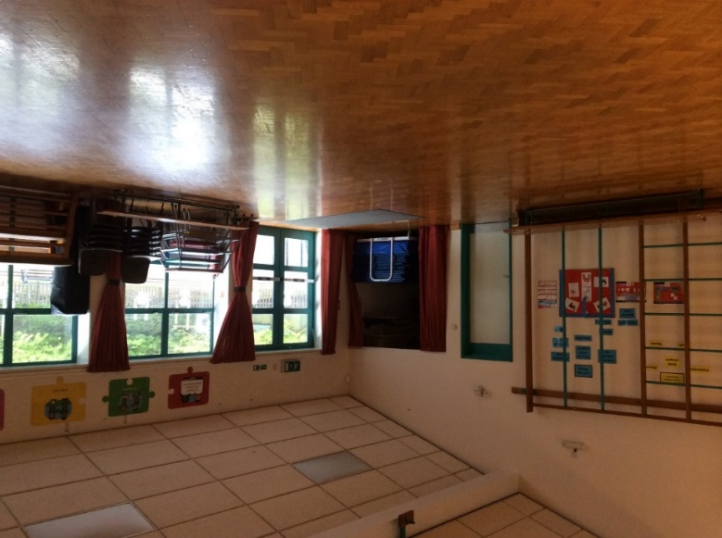

This is the main school hall, where we will have P.E lessons, eat our lunch and have assemblies.

**Playground**

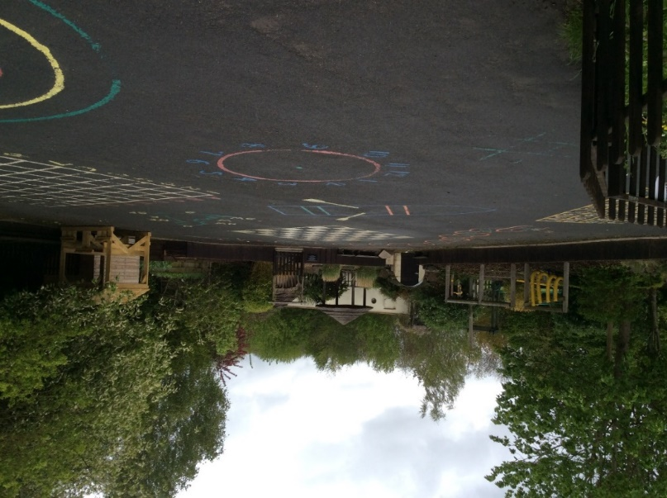This is the playground where we go out to play at lunch time.

We look forward to meeting you soon and welcoming you to the Finstall family.

From all the Reception Team at Finstall First School.

