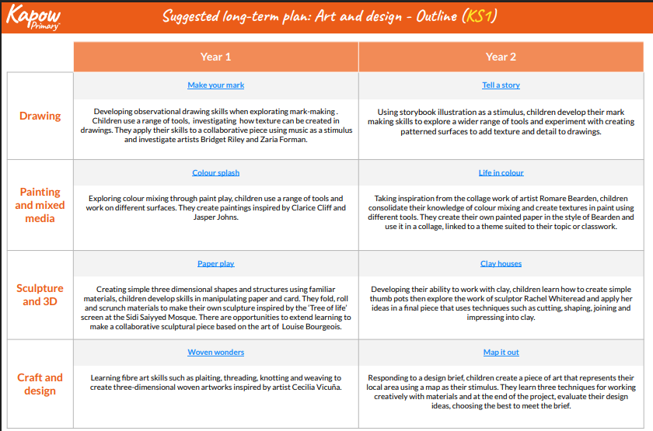Year 1 and 2 Curriculum overview for Art and Design