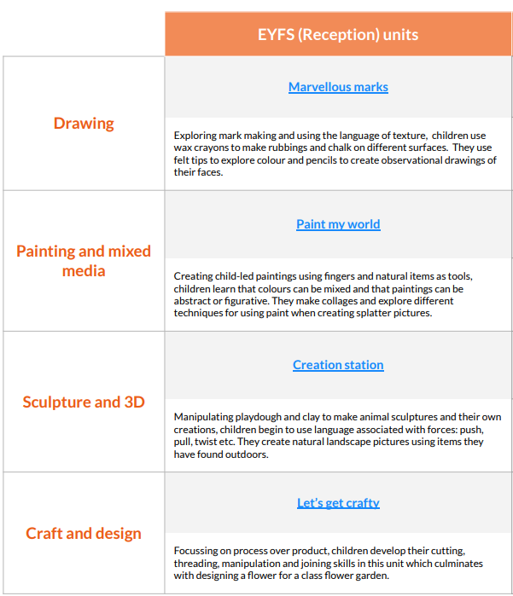This is the overview for EYFS. Art and Design is delivered through continuous provision and discreet skills are taught as needed throughout the year.