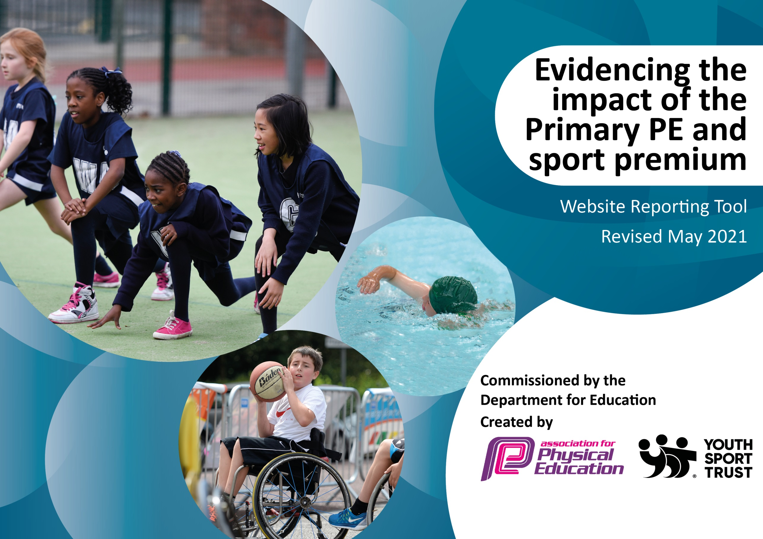

It is important that your grant is used effectively and based on school need. The Education Inspection Framework (Ofsted 2019 p64) makes clear there will be a focus on ‘whether leaders and those responsible for governors all understand their respective roles and perform these in a way that enhances the effectiveness of the school’.

Under the Quality of Education criteria (p41) inspectors consider the extent to which schools can articulate their curriculum (INTENT), construct their curriculum (IMPLEMENTATION) and demonstrate the outcomes which result (IMPACT).

To assist schools with common transferable language this template has been developed to utilise the same three headings which should make your plans easily transferable between working documents.

Schools must use the funding to make additional and sustainable improvements to the quality of Physical Education, School Sport and Physical Activity (PESSPA) they offer. This means that you should use the Primary PE and sport premium to:

- Develop or add to the PESSPA activities that your school already offer
- Build capacity and capability within the school to ensure that improvements made now will benefit pupils joining the school in future years
- The Primary PE and sport premium should not be used to fund capital spend projects; the school’s budget should fund these.
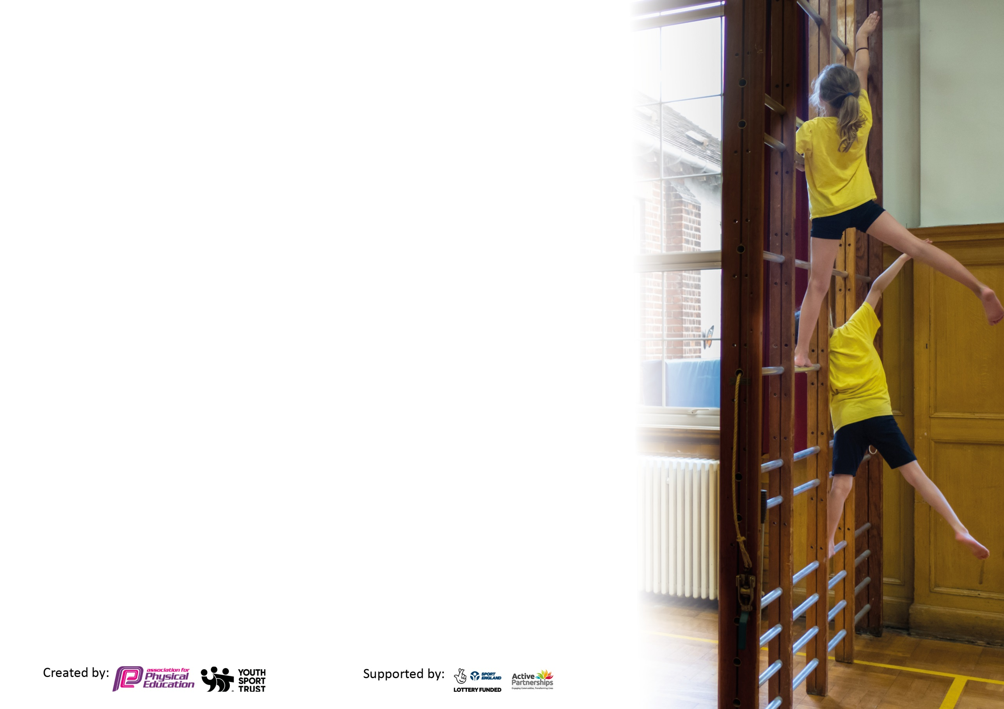
Please visit gov.uk for the revised DfE guidance including the 5 key indicators across which schools should demonstrate an improvement. This document will help you to review your provision and to report your spend. DfE encourages schools to use this template as an effective way of meeting the reporting requirements of the Primary PE and sport premium.

We recommend you start by reflecting on the impact of current provision and reviewing the previous spend.

Schools are required to publish details of how they spend this funding, including any under-spend from 2019/2020, as well as on the impact it has on pupils’ PE and sport participation and attainment by the end of the summer term or by 31st July 2021 at the latest.

We recommend regularly updating the table and publishing it on your website throughout the year. This evidences your ongoing self-evaluation of how you are using the funding to secure maximum, sustainable impact. Final copy must be posted on your website by the end of the academic year and no later than the 31st July 2021. To see an example of how to complete the table please click HERE.

Please note: Although there has been considerable disruption in 2020 it is important that you publish details on your website of how you spend the funding - this is a legal requirement.
Support for review and reflection - considering the 5 key indicators from DfE, what development needs are a priority for your setting and your pupils now and why? Use the space below to reflect on previous spend and key achievements and areas for development.

N.B. In this section you should refer to any adjustments you might have made due to Covid-19 and how these will influence further improvement.
Key achievements to date until July 2020: | Areas for further improvement and baseline evidence of need:
Regular virtual competitions and events.  Wellbeing resource utilised to support PSHE recovery curriculum.  Online learning supported by PE resources.  Use of PE to support activities ‘together’ online, e.g. the live GoNoodle sessions.  Resources for each bubble to use both on the playground and during PE lessons so lessons don’t have to be compromised by lack of resources and activity can be promoted. | Continuation of previous achievements.  To make further use of outdoor space to make sure children have as much opportunity to access time to be active as possible.  Training for staff on how to bring activity into other areas of the curriculum.

Did you carry forward an underspend from 2019-20 academic year into the current academic year? YES Delete as applicable
Total amount carried forward from 2019/2020 £4,457 (-£2,270 already deducted on equipment for Autumn term)
+ Total amount for this academic year 2020/2021 £18,410
= Total to be spent by 31st July 2021 £22,867

Total Spent= £24,006
Meeting national curriculum requirements for swimming and water safety.

N.B Complete this section to your best ability. For example you might have practised safe self-rescue techniques on dry land which you can transfer to the pool when school swimming restarts.
Due to exceptional circumstances priority should be given to ensuring that pupils can perform safe self rescue even
if they do not fully meet the first two requirements of the NC programme of study.
What percentage of your current Year 6 cohort swim competently, confidently and proficiently over a distance of at least 25 metres?  N.B. Even though your pupils may swim in another year please report on their attainment on leaving primary school at the end of the summer term 2021.  Please see note above. | 0% First School and Covid restrictions have not made swimming possible.
What percentage of your current Year 6 cohort use a range of strokes effectively [for example, front crawl, backstroke and breaststroke]?  Please see note above. | 0%
What percentage of your current Year 6 cohort perform safe self-rescue in different water-based situations? | 0% Year 3 study water safety procedures.
Schools can choose to use the Primary PE and sport premium to provide additional provision for swimming but this must be for activity over and above the national curriculum requirements. Have you used it in this way? | No (but under ‘normal’ circumstances we would.)

Action Plan and Budget Tracking
Capture your intended annual spend against the 5 key indicators. Clarify the success criteria and evidence of impact that you intend to measure to evaluate for pupils today and for the future.

Academic Year: 2020/21 | Total fund allocated: £22,867 | Date Updated: July 2021
Key indicator 1: The engagement of all pupils in regular physical activity – Chief Medical Officers guidelines recommend that primary school pupils undertake at least 30 minutes of physical activity a day in school |  |  |  | Percentage of total allocation:
 |  |  |  | 91.7%
Intent | Implementation |  | Impact
Your school focus should be clear what you want the pupils to know and be able to do and about  what they need to learn and to  consolidate through practice: | Make sure your actions to achieve are linked to your intentions: | Funding allocated: | Evidence of impact: what do pupils now know and what can they now do? What has changed?: | Sustainability and suggested next steps:
To engage all children in regular physical activity during playtime  To ensure children have the opportunity to be physically active for at least 30 minutes of each day in school and to encourage 30 minutes outside of school hours.  To develop and improve our general outdoor learning equipment to encourage all children to be active.  Active Maths  CPD provided for staff on how to include activity in other subject areas  Bike skills taught in Year 4  All PE equipment safety checked and fit for purpose | Sports equipment for each bubble to be purchased so equipment can be used every playtime to encourage activity.  To develop the ‘Fabulously Fit at Finstall’ ethos and to incorporate additional sports that children do outside of school using equipment available to them at home during lockdown.  Participation in virtual festivals.  Joining in with GoNoodle challenges with other schools in our cluster.  Foundation stage to purchase a range of equipment that can further extend their use of the outdoor area. Outdoor structures to provide some shelter and storage to outdoor equipment.  This will encourage children who generally don’t actively take part in traditional PE to be active in other ways.  General outdoor equipment provided for other Year groups to encourage more learning to be outside and active.  Track created around the field to allow access to that space even in wet weather conditions. This will also allow for classes to be spaced out, playground with playground equipment, adventure playground, sensory garden and now field. This is an ongoing action, to be completed for September 2021.  Outdoor storage boxes purchased to make the equipment more accessible and to be able to look after the equipment. ‘Trugs’ to allow children to transport, and have ownership, of their own equipment.  Active Maths scheme to be purchased to encourage more activity and use of the outdoor space during Maths lessons.  As part of our ‘Active Maths’ package staff will receive online training on how to most effectively use the resource during Staff meeting time. This will focus on how to engage pupils through activity in other subjects. This will mainly look at how to utilise the Active Maths package but will also include how to use activity, and it’s benefits, in other curriculum areas.  Bikeability training for all Year 4 children.  Gymnasium inspection to allow gym equipment to be used with assurance of it’s safety. | £2505 Autumn term equipment (bats, ball, skipping ropes, bean bags and hoops to be used on the playground.)  Additional sports Day equipment to allow a covid friendly Sports Day to take place £107  £2178 (All Active Academy subscription)  Part of the AAA offer  Part of the AAA offer  2 arches £373  Maths Shed £361  Reading shed £416  £613 Spring term equipment purchase for the new topics covered.  £13,800  8x carrying caddies for Years 1-4 £215 plus two for dinner staff £40  Storage units for equipment to be to hand for each year group £429 for storage boxes for each year group  £545  AAA package  £300  £95 | Each bubble was able to participate in activity during lunch times and break. Skipping ropes, bats and balls and hoops etc allowed different activities to keep children engaged during playtimes and lunchtime. Teachers could focus and engage inactive children effectively at playtimes. The positive impact can be seen in our behaviour log with far fewer incidents during playtimes and lunch times. Social skills groups utilised the bubbles PE and playtime equipment to use activity in the intervention group, and promote activity as a well being tool.  The All Active Academy subscription allowed us to use the homework ideas and allow children to continue with PE objectives using resources available to them at home during lockdown. This was seen in email correspondence between parents and staff during lockdown. This can be seen in good Foundation subject coverage and results across school.  PE planning from AAA utilised for online learning using resources that parents and children would have available to them at home. This is evidenced from feedback via email from parents showing some of our children remaining regularly active.  We could also take part in virtual events through the All Active Academy: Football festival, Winter and Summer School games, Primary learning and discovery festival, and the Primary learning and Discovery virtual festival and these festivals could also be utilised by the home learners and celebrated. Lower school children won one of the events as part of the festival, and received medals, and their achievements were placed on our newsletter home.  Santa Dash- record of participation  Go Noodle challenges alongside our cluster schools have also been taken up each time they are provided and Finstall children have participated, both at home, and at school. We received certificates each time we were involved.  Evidence found in Foundation stage planning with reference to the equipment in the English and Maths sheds. More ‘active learning’ visible in Maths and English with an active element to the Maths and English referred to in each lesson.  Equipment can be seen to be used every playtime and lunchtime. Time table showing rotation of outside spaces so all children can utilise the equipment and resources.  This is to be done over the Summer so impact to be measured next academic year. Use of the track to be timetables into our other ‘active’ areas we are now able to use with covid restrictions being lifted, including the climbing wall, the sensory garden, and the adventure playground.  Lists of equipment given to each bubble. Time table of playtimes and lunchtimes. Staff and lunchtime supervisors using the trugs and the storage boxes to rotate the equipment.  This was completed in May, after being postponed due to lockdown. Planning to be looked at during the Autumn term to see if the scheme is being utilised effectively.  Staff survey in September to see how staff are getting on with this and moderation of the subject.  Register of children attending and lists of children who achieved their certificate.  Gymnasium inspection report | Equipment for ‘alternative’ sports such as boccia to be purchased to encourage more inclusive sports to be played generally.  Active travel promotion.  Mapping out of the school to be used in cross curricular activities.  Further ‘outdoor activity’ equipment e.g. logs and balancing items to be provided to use whilst children travel around the new track as ‘stopping’ points to add alternative activities.  Equipment ‘monitors’ for each class.
Key indicator 2: The profile of PESSPA being raised across the school as a tool for whole school improvement |  |  |  | Percentage of total allocation:
 |  |  |  | 5.7%
Intent | Implementation |  | Impact
Your school focus should be clear what you want the pupils to know and be able to do and about  what they need to learn and to  consolidate through practice: | Make sure your actions to achieve are linked to your intentions: | Funding allocated: | Evidence of impact: what do pupils now know and what can they now do? What has changed?: | Sustainability and suggested next steps:
To continue to develop the PE curriculum across school to help children re engage with their learning  Identifying gaps in learning.  Ensuring that we are catering for our children’s mental health and well being (feeling good and functioning well)  To use Sport’s events as a stimulus for learning and raise the profile of PE and Games in other curriculum areas. | Use CPD hours from the All Active Academy to update PE units, where required, and make sure there is a range of skills taught without repetition. To continue to develop the skills progression across the school.  School sports partnership additional planning to be used to bridge gaps in children’s key skills and assist teaching PE and Games at home.  Staff consulted to see where gaps were in the foundation subject and how they could ‘catch up’ in any areas of learning missing.  After school clubs to be utilised to support children’s social and team building skills, identified as lacking by class teachers. Offered for free to children.  Use resources and outside agencies to support our delivery of wellbeing techniques children can utilise.  Use wellbeing resources provided by the AAA to increase it’s profile and importance during the school day.  Use the AAA homework and newsletters to link to PE and well being learning and engage learners at home.  To use sporting events like the Olympics and the World Cup to inspire cross curricular learning.  To continue to have strong links with the cluster schools (in a virtual format competitions and festivals).  Healthy schools/wellbeing week | See above (All Active Academy subscription)  Staff training time-free  Duke Yoga- £200  Multiskills- £0  Tennis- £196 + £245  Hockey- £125 +£125  Football£180+£150  Yoga -see above  Free Kidderminster Harriers Healthkick course  OAA subscription  OAA subscription  Competition offer as part of our subscription to the AAA  Tag rugby from Worcester Warriors- £100  Ben Bevins- Multiskills with Reception -£50  Cricket was part on a free initiative run by WCCC | PE skills progression updated.  PE planning (‘Plan B’) utilised for online PE and Games learning using resources that parents and children would have available to them at home. This is evidenced from feedback via email from parents showing some of our children remaining regularly active. Children partaking on live zoom ‘GoNoodle activities, enjoying activity with their peers.  Record of curriculum objectives covered by staff in each Year group, and their termly planning  Reception-Yoga (in school time)  Year 1- multi skills club register  Year 2 – Tennis Register  Year 3- hockey club register  Year 4- Football club register  All Reception children were given tools that could be practised after the yoga series of lessons. Children’s participation in the course of lessons was excellent.  Year 4 took part in the 6 themed football tackling Regular Exercise, Healthy Eating, Smoking, Emotional Health & Wellbeing, Dental Care, First Aid & Road Safety  Year 4 could identify ways of making their lives ‘more healthy’ at the end of the course.  Staff used the ‘Wellbeing’ resources provided by the All Active Academy alongside our Jigsaw PSHE ‘Recovery’ package to make sure that PSHE opportunities and well being took a priority in the curriculum (see September timetables). Staff were able to utilise the resources to help run ‘nurture groups’ and provide additional support to those children that required it. Wellbeing questionnaire filled out at the start, and at the end of the year, by children in Year 1 and Year 3 to assess whether they have a greater understanding of looking after their mental health.  Wellbeing newsletters sent out with school newsletter at the end of each term.  A Year 4 team won the virtual ‘fundamentals of football’ event run by the All Active Academy and a Year 1 class won the Primary learning and discovery festival run by Chadsgrove school. Children across school took part on the event. Children also took part in the Autumn and Summer Games virtually, linked to our Heathy School week and Sport’s Day’s, respectively. Record sheets of children’s scores and letters home evidence these.  All of Key Stage 1 and Reception took part in an Olympic/Paralympic festival at the end of the school year.  During ‘Healthy School’s week’ the children had the chance to have a go at a variety of activities in School, delivered by visiting coaches:  Year R – Multi-skills with a Sports coach (Wednesday 21st October) Year 1 – Cricket with coaches from Worcestershire CCC (Thursday 22nd October)  Year 2 – Cricket with coaches from Worcestershire CCC (Thursday 22nd October)  Year 3 – Rugby with coaches from Worcester Warriors (Tuesday 20th October)  Year 4 – Rugby with coaches from Worcester Warriors (Tuesday 20th October) | Use CPD hours from the All Active Academy to update PE units for each year group on an alternative sport and to continue to develop the skills progression across the school.  Additional swimming to allow the Year 3 children to catch up with the swimming they missed due to covid restrictions.

Key indicator 3: Increased confidence, knowledge and skills of all staff in teaching PE and sport |  |  |  | Percentage of total allocation:
 |  |  |  | 1.7%
Intent | Implementation |  | Impact
Your school focus should be clear | Make sure your actions to | Funding | Evidence of impact: what do | Sustainability and suggested
what you want the pupils to know | achieve are linked to your | allocated: | pupils now know and what | next steps:
and be able to do and about | intentions: |  | can they now do? What has
what they need to learn and to |  |  | changed?:
consolidate through practice:
To continue to develop the PE curriculum across school.  Ensure that staff are able/capable of teach all areas of PE and games to a good or better level. | To continue to provide CPD for staff in areas they have identified, including those offered by All Active Academy.  To analyse the PE assessment data from this year to monitor the impact of the ‘Deeper Understanding’ statements on any inconsistencies in the data. We worked with other staff to make sure there is a continuation of learning and gaps can be plugged, either this year, or going into the next year group.  To identify gaps in resources / equipment and purchase according to priority.  Use staff meeting time to pass on new information/skills to the staff after training.  Coaches and All Active Academy staff coming in and supporting school staff in specific lessons. We focused on areas where the curriculum was being updated so this included:  Year 2- Games (OAA CPD)  Year 4-Dance (Autumn and Summer)  Year 3 and 4- Football  Year 4 -Rugby | £78  During staff training time- free  See previous price quoted  £350 | Safety in PE resource book purchased for staff to be able to refer to. Staff were more confident to risk assess during covid times and all PE activities were able to continue following covid restrictions, e.g. staff were happy to continue with Gymnastics teaching using the guidance.  Resources mentioned previously were purchase to allow staff to make the maximum use out of time outside, at both playtime, and during timetabled PE slots during a time when resources were not able to be shared between ‘bubbles’. This allowed all staff to complete all units of work planned across the Games and PE curriculum, except swimming.  Active Maths training provided  Year 2 Tas teach the Games in PE and worked with the AAA support to update their planning. She modelled a lesson with them using their class and the Tas have felt much more confident teaching the games for the remainder of the year.  Year 4 Dance needed updating so we asked an outside dance teacher to support the teaching during the Summer term to help inform planning for next year. | To give out the yearly staff questionnaire to gain an understanding of further staff CPD requirements so that we can continue to develop staff’s subject knowledge and confidence.
Key indicator 4: Broader experience of a range of sports and activities offered to all pupils |  |  |  | Percentage of total allocation:
 |  |  |  | 0.9%
Intent | Implementation |  | Impact
Your school focus should be clear | Make sure your actions to | Funding | Evidence of impact: what do | Sustainability and suggested
what you want the pupils to know | achieve are linked to your | allocated: | pupils now know and what | next steps:
and be able to do and about | intentions: |  | can they now do? What has
what they need to learn and to |  |  | changed?:
consolidate through practice:
To continue to adapt the PE curriculum to include a broader range of sports and activities  More outdoor activity encouraged, not directly ‘PE’  To continue to ensure children of all abilities are engaged and motivated by PE and games inside and outside of lesson time. | We made sure a unit of OAA is covered by all year groups and additional equipment was purchased.  To further develop and strengthen links with community clubs (in school and after school clubs). These have included the local tennis club, hockey club, Worcestershire county cricket, Worcester Warriors, Kidderminster Harriers.  Year 4 were able to access Bhangra dance virtually.  Year 4 used a Dance coach in the Summer term to support the new unit of work, in person, in the Summer term.  The purchase of more outdoor equipment, shelter and storage and the track around the field will allow for as many children as possible to utilise the outdoor space and maximise the amount of time they are active during play times and lunchtimes (as identified in indicator 1)  Free after school clubs were offered to all Key Stage 1 and Key Stage 2 children and Foundation stage children had free Yoga teaching in curriculum time and children who are less active that showed an interest were targeted.  Curriculum time additional sports were available too: Outside clubs that came in included Worcestershire cricket club, ‘Chance to Shine’ in Years 1 and 2, ‘skills blast’ in Year 2 and Kidderminster Harriers ‘Healthkick’ for Year 4, Kidderminster Harriers ‘fun sessions’ one per year group or the rest of school. Bhangra dancing for Year 4 children.  Classes participated in GoNoodle challenges alongside other school each month, run by the All Active Academy. These were also flagged to children learning at home.  This year’s Year 3 spoken to ascertain interest in who would like to be considered to be in next Year’s Sport’s crew. These children can run alternative activities for others in their ‘bubble’ group to do. Training of these children to take place in September.  Took part in the Primary learning and discovery festival run by Chadsgrove school. | Part of the Spring term equipment mentioned previously  £50  £100  £60  See track and equipment amount outlined above  See costings above.  Sessions were free except Bhangra dance outlined  AAA offer  Free  Part of the AAA offer | Year 3 and Year 4 OAA planning and resources purchased. Other Year groups utilised the updated planning from the end of the last academic year. Pupils progress in areas such as team building and working collaboratively can be seen on the Foundation stage assessments.  Ben Bevins came in and ran a multi skills session or each Reception class. This improved their balancing and throwing and catching techniques, and also gave staff new ideas to use in their own teaching. This can be seen on the Early Years profile results.  Tag rugby coaching from the Worcester Warriors offered children the Year 3 and 4 children the opportunity to be taught by Rugby players. This allowed them to meet the learning objectives for the Rugby unit of work even though the unit wasn’t able to be taught, in full, during lesson time, due to lockdown restricting the curriculum time spent on each unit. This is reflected in the Foundation stage assessment of invasion games in PE in Year 3 and Year 4.  Ideas from the coaches used to inform the new planning and make sure there is progression in the teaching of Dance.  The impact of this can measured next year when the work is complete. Playtimes and lunchtimes had less behaviour incidents.  14-16 children in each class, including those identified as ‘less active’ could be targeted and took part in a club.  All children got to take part in additional sport’s sessions and experience a different sport. Links to clubs linked to the coaches were signposted.  Classes across school accessed this and emails were sent home with the link and home learners could be seen to participate each week.  Year 3 children completed a application to be on the Sport’s Crew or play leaders. The impact will be measured next term.  Children in Key Stage 1 and Key Stage 2 took part. Results form completed. Year 1 class won the event. | To include an alternative sport into some Year groups to motivate children of all abilities.  To make stronger links between Finstall and Chadsgrove/Rigby Special Schools (if and when covid restrictions allow).  Further ‘outdoor activity’ equipment e.g. logs and balancing items to be provided to use whilst children travel around the new track as ‘stopping’ points to add alternative activities.

Key indicator 5: Increased participation in competitive sport |  |  |  | Percentage of total allocation:
 |  |  |  | 0%
Intent | Implementation |  | Impact
Your school focus should be clear | Make sure your actions to | Funding | Evidence of impact: what do | Sustainability and suggested
what you want the pupils to know | achieve are linked to your | allocated: | pupils now know and what | next steps:
and be able to do and about | intentions: |  | can they now do? What has
what they need to learn and to |  |  | changed?:
consolidate through practice:
To offer a range of competitive events to help to include more children in competitive sport. | To continue to offer as many chances (virtually) for different year groups to be involved in competitions run by the All Active Academy. We took part in the Summer and Winter Games and the virtual football competition. This included links to the Paralympic and Olympic games. Scores were recorded and sent in. Year groups in school won both the Winter School Games and the virtual football competition.  “Level Zero” competitions to help improve children’s skills were included in each games unit and through online teaching activities and competition through the All Active Academy.  All Active Academy came in and ran a Paralympic/Olympic festival for all of Foundation and Key stage 1 to take part in.  Outside clubs that came in also ran mini competitions with the children. These included the cricket club, ‘Chance to Shine’ in Years 1 and 2, ‘skills blast’ in Year 2 and Kidderminster Harriers ‘Healthkick’ for Year 4, Kidderminster Harriers ‘fun sessions’ one per year group or the rest of school. | Free as part of the AAA offer  Free as part of the AAA offer  Free as part of the AAA offer  Free as part of offer made from local clubs. | All children have taken part in some level of competition. Results celebrated on our school newsletter. | When covid restrictions lift, to make sure we make the most of competitions offered as part of our All Active Academy subscription, and any competitions offered by local sport’s clubs.

Signed off by
Head Teacher:
Date:
Subject Leader:
Date:
Governor:
Date:

