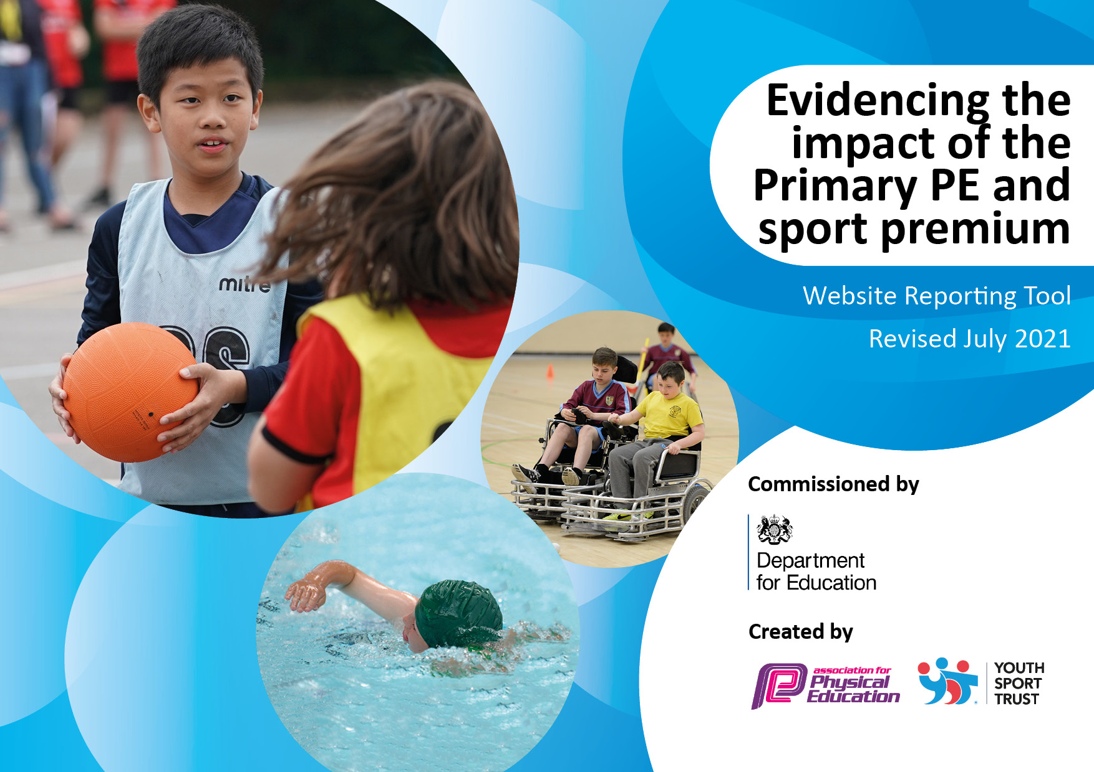
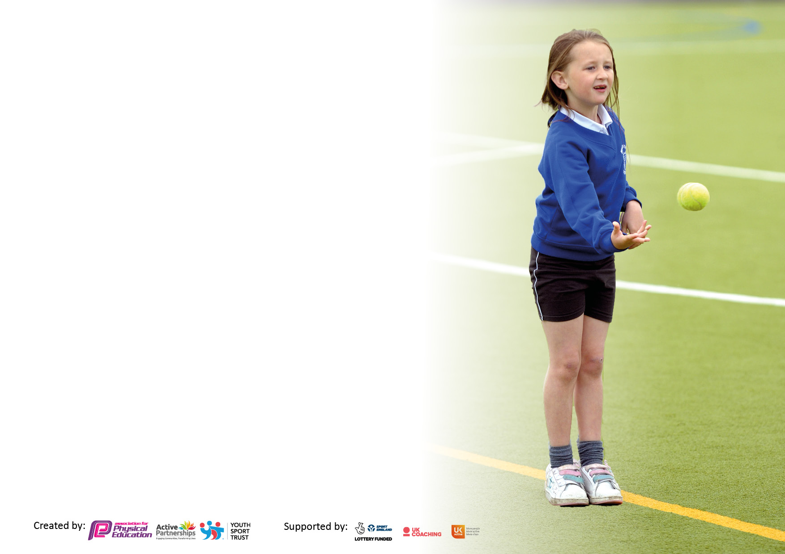

It is important that your grant is used effectively and based on school need. The Education Inspection Framework makes clear there will be a focus on ‘whether leaders and those responsible for governors all understand their respective roles and perform these in a way that enhances the effectiveness of the school’.

Under the Quality of Education Ofsted inspectors consider:
Intent - Curriculum design, coverage and appropriateness
Implementation - Curriculum delivery, Teaching (pedagogy) and Assessment
Impact - Attainment and progress

To assist schools with common transferable language this template has been developed to utilise the same three headings which should make your plans easily transferable between working documents.

Schools must use the funding to make additional and sustainable improvements to the quality of Physical Education, School Sport and Physical Activity (PESSPA) they offer. This means that you should use the Primary PE and sport premium to:

- Develop or add to the PESSPA activities that your school already offer
- Build capacity and capability within the school to ensure that improvements made now will benefit pupils joining the school in future years
- The Primary PE and sport premium should not be used to fund capital spend projects; the school’s budget should fund these.

Pleasevisitgov.ukfortherevisedDfEguidanceincludingthe5keyindicatorsacrosswhichschoolsshoulddemonstrate animprovement.Thisdocumentwillhelpyoutoreviewyourprovisionandtoreportyourspend.DfEencouragesschools to use this template as an effective way of meeting the reporting requirements of the Primary PE and sport premium.

We recommend you start by reflecting on the impact of current provision and reviewing the previous spend.

Schools are required to publish details of how they spend this funding, including any under-spend from 2019/2020, as well as on the impact it has on pupils’ PE and sport participation and attainment. All funding must be spent by 31st July 2022.

We recommend regularly updating the table and publishing it on your website throughout the year. This evidences your ongoing self-evaluation of how you are using the funding to secure maximum, sustainable impact. Final copy must be posted on your website by the end of the academic year and no later than the 31st July 2021. To see an example of how to complete the table please click HERE.

Details with regard to funding
Please complete the table below.

Total amount carried over from 2020/2021 | Minus £1,119.00
Total amount allocated for 2021/22 | £18,400 but £17,281 when over expenditure taken off.
How much (if any) do you intend to carry over from this total fund into 2022/23? | £0.00
Total amount allocated for 2022/23 | £18,404
Total amount of funding for 2022/23. To be spent and reported on by 31st July 2023. | £18,404
Swimming Data
Please report on your Swimming Data below.

Meeting national curriculum requirements for swimming and water safety.

What percentage of your current Year 4 cohort swim competently, confidently and proficiently over a distance of at least 25 metres?  N.B. Even though your pupils may swim in another year please report on their attainment on leaving primary school at the end of the summer term 2023.  Please see note above | 87% (52 / 60)
What percentage of your current Year 4 cohort use a range of strokes effectively [for example, front crawl, backstroke and breaststroke]?  Please see note above | 67% (40 / 60)
What percentage of your current Year 6 cohort perform safe self-rescue in different water-based situations? | Not recorded
Schools can choose to use the Primary PE and sport premium to provide additional provision for swimming but this must be for activity over and above the national curriculum requirements. Have you used it in this way? | Yes - £1,094.90 to provide additional swimming sessions beyond the first 20 lessons (for those who still couldn’t swim 25 metres).

Action Plan and Budget Tracking
Capture your intended annual spend against the 5 key indicators. Clarify the success criteria and evidence of impact that you intend to measure to evaluate for pupils today and for the future.

Academic Year: 2022/23 | Total fund allocated: £18,404 | Date Updated: 27.07.23
Key indicator 1: The engagement of all pupils in regular physical activity – Chief Medical Officers guidelines recommend that primary school pupils undertake at least 30 minutes of physical activity a day in school |  |  |  | Percentage of total allocation:
 |  |  |  | 43.4%
Intent | Implementation |  | Impact
Your school focus should be clear what you want the pupils to know and be able to do and about  what they need to learn and to  consolidate through practice: | Make sure your actions to achieve are linked to your intentions: | Funding allocated: | Evidence of impact: what do pupils now know and what can they now do? What has changed?: | Sustainability and suggested next steps:
Highlight the importance of being active throughout the day, especially during break times and lunch times.  To ensure the children have the opportunity to be physically active for at least 30 mins of each day in school and to encourage at least 30 mins outside of school hours. | Provide outdoor gym and fitness equipment around the outside of the running track on the field. This will provide activity for up to 12 different children at any one time.  Boards to display “Break time Challenges” promoting being ‘active’.  Wide range of equipment and resources available to children at break and lunch times including bouldering wall, sensory garden, adventure playground, running track as well as a wide range of play equipment.  Annual Inspection of outdoor play equipment.  Year 4 children to participate in Bike-Ability to ensure they can ride their bikes safely.  Subscription to All Active Academy who provide a range of sporting opportunities.  After-School Clubs to allow more children to be active throughout the day.  A range of sports provided during Sports Week to bring awareness of the benefits of sport and spark interest in a sport they could participate in outside of school.  Disadvantaged (PP) children to be taken to a Pupil Premium Event run by the All Active Academy. | £7,500  £127.37  £131.86  £150  £255  £2,178  £1,809.70  £778.29  £80 | Impact will be measurable after the equipment is installed in July / August 2023.  Noticeboards purchased and populated with “Break time Challenges,” which encouraged children to attempt the challenges and record their personal bests. Children more aware of how they have improved their performance against the various challenges.  Higher % of children are engaged in physical activity, including challenges, at break and lunch times.  Play equipment is safe for children to use.  All Yr 4 children took part in bike-ability training so their bikes were safe and they could ride them safely.  Children have access to a range of competitions and different sports through AAA and staff have increased CPD opportunities.  This year, children have had access to the following After School clubs:  Football – Yrs 3, 4  Gymnastics – Yrs 1, 4  Irish Dancing – Yrs 1, 2  Hockey – Year 3  Tennis – Year 2  Tag Rugby – Year 4  Golf – Year 3  Bell-boating – Year 4  This has encouraged children to continue with such sports in external clubs.  Activities such as Gymnastics, Martial Arts, Irish Dancing, Yoga and Basketball were provided for children who didn’t access these as after school clubs. This has encouraged children to continue with such sports in external clubs.  Disadvantaged children attended PP event, run by AAA, which exposed them to a range of sports to encourage them to continue with these outside school. | Teach children how to use the equipment as part of a circuit around the track. The equipment should provide different fitness activities for many years to come.  This will continue and children will be able to use new outdoor gym and fitness equipment as additional challenges too.  Continue to ensure plentiful equipment is available to the children and that challenges are refreshed and celebrated to encourage continued use.  Annual check to be completed.  Continue to participate in Bike-ability scheme with year 4 children and maybe extend to Yr R with balance bikes.  We will continue to work in partnership with AAA to access high-quality support and advice, staff CPD and opportunities for children to access competitions and different sports.  Continue to offer children a range of after school clubs so that many children have access to physical activity after school and they are encouraged to continue with physical activity outside of school as part of a healthy life.  Continue to offer new and alternative sports to children during School Sports Week to encourage them to participate in external clubs outside of School.  Through AAA, continue to take PP children to such events in future to encourage them to continue with participation in sport outside School.
Key indicator 2: The profile of PESSPA being raised across the school as a tool for whole school improvement |  |  |  | Percentage of total allocation:
 |  |  |  | 33.2%
Intent | Implementation |  | Impact
Your school focus should be clear what you want the pupils to know and be able to do and about  what they need to learn and to  consolidate through practice: | Make sure your actions to achieve are linked to your intentions: | Funding allocated: | Evidence of impact: what do pupils now know and what can they now do? What has changed?: | Sustainability and suggested next steps:
To continue to develop the PE curriculum across the school and to ensure children of all abilities are engaged and motivated by PE during lesson time.  To develop mindfulness and good mental well-being within the PSHE curriculum.  To provide all-year-round access to Sensory Garden as a space to develop children’s well-being / mental health. | Continue to have strong links with cluster schools through the meetings provided in All Active Academy. PE Lead networks with other PE Leads to share ideas, developments and areas for improvement.  Update and refine the PE skills Progression Map.  Use CPD hours from the All Active Academy to update PE units in Years 2 and Year 4 so they are in line with other year groups.  To subscribe to Jigsaw – The Mindful Approach to teaching PSHE.  Permanent pathway to be laid through the Sensory Garden to provide all-year round access. Repair of posts. | £2,178  £500  £600  £4,200  £130 | During monitoring of PE, and the PE curriculum in particular, in the Spring Term, areas for improvement were identified.  PE Lead went on maternity leave at end of Spring Term 2023. Non-specialist, in temporary role, has done her best to manage the subject since taking over. Did a particularly good job in organising School Sports Week and both Lower and Upper School Sports Days.  Some improvements made to Progression Map but work will need to be completed to further improve the PE Skills Progression Map.  Not completed by SL prior to going on maternity leave and will need to be carried over to next year.  Children say they enjoy the calm nature of PSHE lessons, which help them to understand themselves and how to stay healthy, both physically and mentally.  Path laid so children are able to access this all year round. Children enjoy using this at break / lunch times – helps with good well-being. | Further work needs to be completed on improving and refining areas of the PE Curriculum, as identified in monitoring that took place during the Spring Term 2023.  Increase monitoring activities for PE during SL release time – - lesson visits, pupil voice, planning scrutiny, quality of assessment, etc.  Temporary SL to receive support from Senior Leaders and the AAA to further improve the PE Skills Progression Map and certain PE Units in Years 2 and 4.  Continue to use Jigsaw for the PSHE curriculum. Annual online subscription will improve access to planning and wider range of updated resources.  Continue to encourage use of Sensory Garden to develop pupils’ well-being and mental health.

Key indicator 3: Increased confidence, knowledge and skills of all staff in teaching PE and sport |  |  |  | Percentage of total allocation:
 |  |  |  | 2.7%
Intent | Implementation |  | Impact
Your school focus should be clear | Make sure your actions to | Funding | Evidence of impact: what do | Sustainability and suggested
what you want the pupils to know | achieve are linked to your | allocated: | pupils now know and what | next steps:
and be able to do and about | intentions: |  | can they now do? What has
what they need to learn and to |  |  | changed?:
consolidate through practice:
Ensure staff are able to / capable of teaching all areas of PE to a good or better level. | Analyse the PE Assessment Data from this year to monitor the impact of the ‘Deeper Understanding’ statements and to identify any inconsistencies in the data.  Teacher questionnaire given out at the start of the year to gain an understanding of any CPD requirements to continue to develop staff’s subject knowledge and confidence.  Staff provided with training on how to use the new planning provided for Year 2 multi-skills lessons.  To identify gaps in resources/ equipment and purchase according to priority. | £100  £514.86 | High % of children attain at least a good level against the PE objectives and a reasonably high % also achieve a higher / deeper level. Slight inconsistencies of understanding of staff judging deeper / higher level of understanding addressed by providing support to individual staff.  Questionnaire told SL that … so…  SL provided training to Year 2 staff on how to use the new planning for Year 2 multi-skills lessons.  Additional equipment purchased as identified to enable the effective delivery of the curriculum and to provide for children at break and lunch times. | Through ongoing monitoring, continue to check that staff have a good understanding of how to judge higher / deeper levels against the PE objectives.  SL to continue to check with staff regarding CPD requirements. Also use Lesson Visits to check that curriculum is being delivered as designed.  Check that staff (CTs and TAs) new to Year 2 are aware of expectations of PE curriculum in Year 2 and provide support as required.  Continue to purchase equipment and resources as required.
Key indicator 4: Broader experience of a range of sports and activities offered to all pupils |  |  |  | Percentage of total allocation:
 |  |  |  | 14%
Intent | Implementation |  | Impact
Your school focus should be clear | Make sure your actions to | Funding | Evidence of impact: what do | Sustainability and suggested
what you want the pupils to know | achieve are linked to your | allocated: | pupils now know and what | next steps:
and be able to do and about | intentions: |  | can they now do? What has
what they need to learn and to |  |  | changed?:
consolidate through practice:
To continue to ensure children of all abilities are engaged and motivated by PE and Sport, both inside and outside of lesson time.  To ensure that all Year 4 children experience OAA activities as part of a residential visit.  To ensure all Year 4 children have the opportunity to take part in bell-boating- a safe way to introduce pupils to water sports.  To provide additional swimming sessions for weaker swimmers after completion of 20 lessons over the Autumn and Spring Terms. | Each year group has 2-hour slots of PE each week.  Use of a playground rota to ensure all children have regular access to playground equipment such as the adventure playground, bouldering wall, running track, sensory garden, etc.  All children across school take part in a ‘Sports Week’ which provides them with the opportunity to take part in alternative sports such as Irish Dancing and Martial Arts.  A large number of children, particularly Years 3 and 4, to take part in a variety of inter-school competitions.  After School clubs, run by external coaches, to offer children the opportunity to take part in a sport after school.  All of the Year 4 children to be given the opportunity to learn some street dance routines in the Summer Term by an external coach.  All the Year 4 children visit the Malvern Hills Boundless Outdoor centre where they are able to take part in OAA activities.  All Year 4 children to go on a ‘Bell boating Journey’ along a local canal.  Children in Years 3 and 4 who cannot swim 25 metres by the end of the Spring Term to attend a further 10 sessions funded by the School. | £778.29  £1,350  (Transport and Supply cover)  £1,809.70  £480  £400  £450  £1,094.90 | High % of children achieve a good level in PE and a reasonably high % achieve a higher / deeper level. Children say they enjoy their PE lessons and understand the benefits that regular exercise and involvement in sports and activities bring. High % of children take part in physical activity at break and lunch time, in after school clubs and outside School.  Activities such as Gymnastics, Martial Arts, Irish Dancing, Yoga and Basketball were provided for children who didn’t access these as after school clubs. This has encouraged children to continue with such sports in external clubs.  Tournaments included:  Football – Yr 4  Hockey – Year 4  Tennis – Year 3  Tag Rugby – Year 4  Golf – Year 3  Bell-boating – Year 4  Pupil Premium – Mixed ages  Children have enjoyed them and have experienced success and disappointment with equally high degrees of sportsmanship.  Clubs have included the following: Football – Yrs 3, 4  Gymnastics – Yrs 1, 4  Irish Dancing – Yrs 1, 2  Hockey – Year 3  Tennis – Year 2  Tag Rugby – Year 4  Golf – Year 3  Bell-boating – Year 4  All Year 4 children received a course of lessons in Street Dance, as part of the Dance aspect of their PE Curriculum.  School supplemented the trip to Malvern and the bell-boating journey so that all children could access them, irrespective of their financial situation. All children accessed a range of OAA activities that they would not normally able to access.  Further 10 lessons provided for weaker swimmers to enable a few more to be able to swim 25 metres by the end of the year. | Ensure that children continue to access at least 2 hours of PE on the curriculum each week.  Continue to promote the benefits of children taking part in regular exercise and being involved in sports and activities at break and lunch times, during after school clubs and outside School.  Continue to offer new and alternative sports to children during School Sports Week to encourage them to participate in external clubs outside of School.  Children to continue to participate in inter-School competitive sport, partly through our involvement in AAA.  Continue to offer children a range of after school clubs so that many children have access to physical activity after school and they are encouraged to continue with physical activity outside of school as part of a healthy life.  Continue to expose children to different forms of dance, from different cultures, within the PE curriculum, as long as the sequence of learning is not disrupted.  Continue to ensure that the residential trip to Malvern and the bell-boating journey are accessible for all children.  Continue to offer this in the Summer Term for children in Years 3 and 4.

Key indicator 5: Increased participation in competitive sport |  |  |  | Percentage of total allocation:
 |  |  |  | 6.7%
Intent | Implementation |  | Impact
Your school focus should be clear | Make sure your actions to | Funding | Evidence of impact: what do | Sustainability and suggested
what you want the pupils to know | achieve are linked to your | allocated: | pupils now know and what | next steps:
and be able to do and about | intentions: |  | can they now do? What has
what they need to learn and to |  |  | changed?:
consolidate through practice:
To offer a range of competitive events to help to include more children in competitive sport. | A large number of children, particularly Years 3 and 4, to take part in a variety of inter-school competitions, partly through the AAA.  All children to be given the chance to compete in a Sports Day – Lower School on the School Field and Upper School at the Ryland Centre Athletics Track.  Level 0 competitions offered by Playleaders as part of their challenges set at breaktimes and lunchtimes. | £1,270  (Transport and Supply cover)  £269.65 | Tournaments included:  Football – Yr 4  Hockey – Year 4 – qualified for County Winter Games  Tennis – Year 3  Tag Rugby – Year 4 - Winners  Golf – Year 3  Bell-boating – Year 4 - Winners  Pupil Premium – Mixed ages  Children have enjoyed them and have experienced success and disappointment with equally high degrees of sportsmanship.  All children took part in a Sports Day and enjoyed the experience. Children were taught to be good sports and were rewarded with stickers for top 3 finishes or for taking part.  Children encouraged to compete with their personal bests in challenges set at break and lunch times. | Children to continue to participate in inter-School competitive sport, partly through our involvement in AAA.  Continue to encourage competitive sport and the expected behaviours that accompany this form of sport. Extend competitions between houses for different sports in future.  Ensure that challenges are refreshed and celebrated to encourage continued use and also include new outdoor gym equipment.

Signed off by
Head Teacher: | Stuart Evans
Date: | 27.07.2023
Subject Leader: | Sophie Law
Date: | 27.07.23
Governor: | Rebecca Miles
Date: | 31.07.2023

