Finstall First School
Reading Spine Books
for Reception to Year 4

At Finstall First School, we want our School to be a place where children are read to, enjoy, discuss and work with high quality books. The 'Reading Spine' is a core of books that create a living library inside a child's mind. It is a store of classics and essential reads that help children engage at a deeper level and enter the world of the story. The books sometimes link to our topics but not always. They are shared with all of the children in different ways – they may be read to the children, used a stimulus for writing in English lessons or as a guided reader whereby children read and respond to them in a small group.

Year 4 Recommended Reading List
Author | Title
Nina Bawden | The Peppermint Pig
Cressida Cowell | How to train your dragon
Gillian Cross | Demon Headmaster
Vince Cross | Blitz
Roald Dahl | Charlie and the Chocolate Factory
Roald Dahl | BFG
Roald Dahl | Georges Marvellous Medicine
Michael Foreman | War Game
Reinhardt Jung | Bambert's Book of Missing Stories
Clive King | Stig of the Dump
Satoshi Kitamura | Stone Age Boy
Mary Norton | The Borrowers
Ian Ogilvy | Measle and the Wrathmonk
Philip Pullman | I was a rat
Philip Pullman | The Firework Makers Daughter
Michelle Robinson | How to wash a woolly Mammoth
David Walliams | Billionaire Boy
EB White | Charlottes Web
Jacqueline Wilson | Cliffhanger
Jacqueline Wilson | The Suitcase Kid

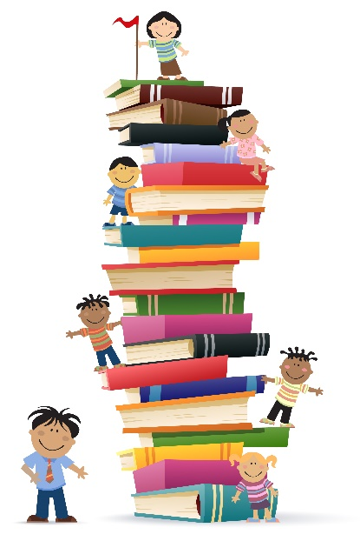

Year 3 Recommended Reading List
Author | Title
Enid Blyton | The Faraway Tree
Jeff Brown | Flat Stanley
Anthony Browne | King Kong
Anthony Browne | Voices in the Park
Betsy Byars | The Midnight Fox
Roald Dahl | Fantastic Mr Fox
Lucy Daniels | Dog in the Dungeon
Kenneth Grahame | The Reluctant Dragon
Ted Hughes | The Iron Man
Eva Ibbotson | The Abominables
Dick King-Smith | The Hodgeheg
Dick King Smith | George Speaks
Dick King Smith | The Sheep Pig
Rudyard Kipling | Just so stories
CS Lewis | The Lion the witch and the wardrobe
Jenny Nimmo | The Witches’ Tears
Philip Pullman | Aladdin and the Enchanted Lamp
Philip Pullman | Puss in boots
Dr. Seuss | Oh, the Places You'll Go
Andy Stanton | You’re a bad man, Mr. Gum! (series)
Jeremy Strong | Romans on the Rampage
Marcia Williams | Greek Myths
Jeanne Willis | Who’s in the Loo?
Jacqueline Wilson | Hetty Feather
Charles Dickens | A Christmas Carol (abridged version)
Juliet Desailly | Ma’ats feather

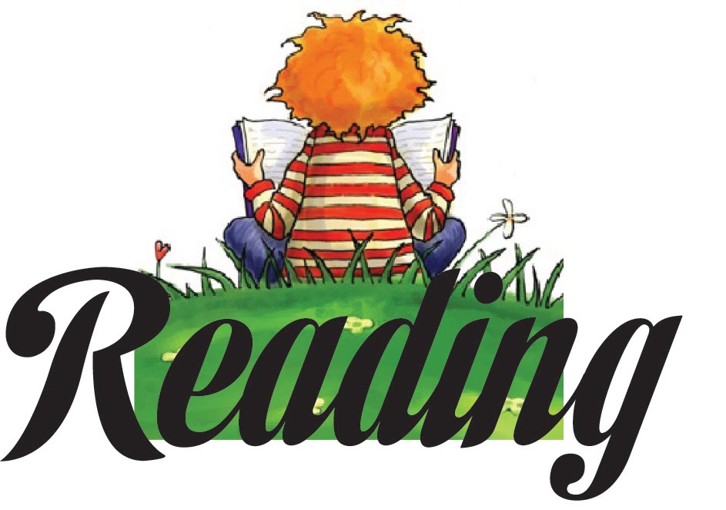

Year 2 Recommended Reading List
Author | Title
Allan Ahlberg | The man who wore all his clothes
Ronda & David Armitage | The Lighthouse Keeper’s lunch
Antonia Barber | The Mousehole Cat
Enid Blyton | The Enchanted Wood
Raymond Briggs | Fungus the Bogeyman
Anthony Browne | Gorilla
Anthony Browne | Hansel & Gretel
Humphrey Carpenter | Mr Majeika
Roald Dahl | The Enormous Crocodile
Roald Dahl | The Magic Finger
Roald Dahl | The Giraffe the peley and me
Roald Dahl | Revolting Rhymes
Drew Daywalt | The day the crayons quit
Lynley Dodd | Hairy Maclary from Donaldson’s dairy
Julia Donaldson | A squash and a squeeze
Julia Donaldson | The Smartest Giant in Town
Julia Donaldson | Tiddler
Max Eilenberg | Cinderella
Jan Fearnley | Mr Wolfs Pancakes
Anne Fine | The Diary of a Killer Cat
Emily Gravett | Meercat Mail
Emily Gravett | Wolves
Kes Graey | Billys Bucket
Mairi Hedderwick | Katie Morag’s Island Stories
Shirley Hughes | Dogger
John Light | The Flower
Margaret Mahy | A Lion in the Meadow
Lemony Snicket | The Dark
Jill Tomlinson | The owl who was afraid of the dark
Martin Waddell | Owl Babies

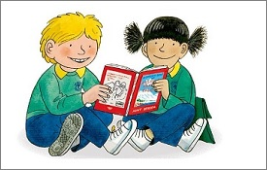

Year 1 Recommended Reading List
Author | Title
Alan and Janet Ahlberg | Cops and Robbers
Raymond Briggs | Jim and the Beanstalk
Eileen Browne | Handa’s Surpise
Eileen Browne | Handa’s Hen
John Burningham | Avacado Baby
Nick Butterworth | The Whisperer
Rod Campbell | Dear Zoo
Lauren Child | Charlie and Lola
Helen Cooper | Pumpkin Soup
Alexis Deacon | Beegu
Lynley Dodd | The Other Ark
Minnie Grey | The Princess and the Pea
Shirley Hughes | Alfie
Pat Hutchins | Don’t Forget the Bacon
Simon James | The Wild Woods
Oliver Jeffers | Lost and Found
Judith Kerr | The tiger who came to tea
Geraldine McCaughrean | Unicorn, Unicorn
David McKee | Not Now, Bernard
David McKee | Elmer
Michael Morpurgo | The Silver Swan
Inga Moore | Six Dinner Sid
Jill Murphy | Peace at Last
Jill Murphy | On the way home
Korky Paul | The Fish Who Could Wish
Marcus Pfister | Rainbow Fish
Maurice Sendak | Where the Wild Things Are
Dr Seuss | The Cat in the Hat
Aleksei Tolstoy | The Gigantic Turnip
Martin Waddell | Farmer Duck
Martin Waddell | Can’t you sleep Little bear

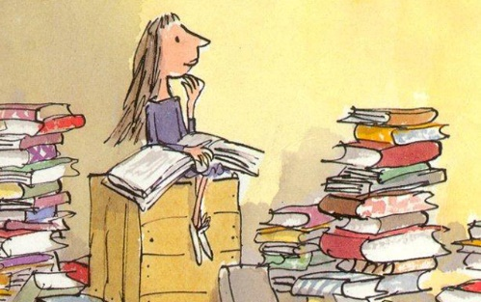

Reception Recommended Reading list
Author | Title
Allan Ahlberg | Each peach, pear plum
Allan Ahlberg | Monkey Do
Nick Barrett | Percy the Park Keeper
Byron Barton | Little Red Hen
Anthony Browne | My Amazing Mum
Eric Carle | The Very Hungry Caterpillar
Eric Carle | Slowly, Slowly, Slowly said the Sloth
Emma Chichester | Where are you, Blue Kangaroo
Emma Chichester | I love you, Blue Kangaroo
Roald Dahl | Esio Trot
Julia Donaldson | What the Ladybird Heard
Julia Donaldson | The Gruffalo
Julia Donaldson | Scarecrows Wedding
Julia Donaldson | Smeds & Smoos
Julia Donaldson | Sharing A Shell
Jonny Duddle | Pirates of Scurvy Sands
Susan Gates | Run! Run! It’s Scarypoo!
Judith Kerr | The Tiger who came to tea
Robert N. Munsch | Love You Forever
Jill Murphy | Peace at Last
Jill Murphy | Whatever Next!
Michael Rosen | We‘re going on a bear hunt
Raynhill Scomel | The Wish Cat
Oscar Seaworthy | Portside Pirates
Nick Sharratt | Pirate Pete
Kaye Umansky | Yo Ho Ho! A Pirating We’ll Go!
Martin Waddell | Owl babies
 | The Three Little Pigs
 | Goldilocks and the three bears
 | The Enormous Turnip
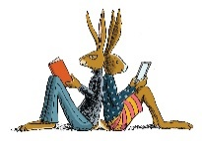

Year group Book Spines
Year 3 | Book title | Class study | Read to class | Linked to class topic | Books that are the class topic | Books available in class library
Autumn 1 | Howard Carter’s Diary entries  The Iron Man  The lion the Witch and the Wardrobe  Flat Stanley  Fantastic Mr Fox  Ma’ats Feather | yes | Yes  yes | Yes  yes | Yes  yes | Yes  Yes  Yes  yes
Autumn2 | Roald Dahl – The Twits.  The Hodgeheg  Just so Stories  Harry the Poinsonous Centipede  Charlottes Web  Gangsta Granny | yes | yes |  |  | Yes  Yes  Yes  Yes  yes
Spring 1 | Coming of the Romans.  The sheep pig  King Kong  The Abominables  Whos in the Loo | Yes | Yes | yes | yes | Yes
Spring 2 | Escape from Pompeii  Magic Box by Kit Wright.  Romans on the Rampage  The Witches tears  Puss in Boots  Aladdin and the Enchanted Lamp | Yes  Yes | Yes  Yes  Yes  Yes  yes | Yes  Yes  Yes | Yes  yes
Summer 1 | Study of performance poetry  Hetty Feather  A Christmas Carol  Voices in the park  Dog in the Dungeon  The Reluctant Dragon  George Speaks | Yes | Yes  Yes  Yes | Yes  Yes  Yes | yes | Yes
Summer 2 | Wallace and Gromit The Wrong Trousers  The Midnight Fox  The Faraway Tree  Oh the places youll go  Youre a bad man Mr Gum  How to train your dragon | Yes | Yes | Yes | yes

Year 1 | Book title | Class study | Read to class | Linked to class topic | Books that are the class topic | Books available in class library
Autumn 1 | Poetry about Ourselves and the senses:  Hairy Maclary  Peace at last  Owl Babies  The Very Hungry Caterpillar  I Hear a Pickle and smell, see touch and taste it too.  Cops and Robbers  Beegu | Yes | Yes  Yes  Yes  Yes  Yes  Yes  Yes  Yes | Yes  Yes  Yes  Yes  Yes  yes | yes | yes  yes  yes  yes  yes
Autumn 2 | Non fiction books with instructions  Can’t you sleep Little Bear  On the way home  The Tiger comes to Tea  The Wild Woods by  Charlie and Lola  The Rainbow Fish | Yes | Yes  Yes  Yes  Yes  Yes  Yes  yes | Yes  Yes  Yes  Yes  Yes  Yes  yes | yes | Yes  Yes  Yes  Yes  Yes  yes
Spring 1 | fairy stories and traditional tales  Goldilocks and the Three Bears.  Hansel and Gretel  Three Little Pigs  Gingerbread Man  Little Red Riding hood  Cinderella  Snow White and the Seven Dwarves.  Dick Whittington  Peter Pan  The Frog Prince  The Billy Goats Gruff  Rumplestiltskin  Rapunzel  Jack and the Beanstalk  Beware of the Bears Mr Wolf’s Pancakes  Jim and the Beanstalk  The Gigantic Turnip  The Princess and the Pea | Yes | Yes | Yes | yes | Yes
Spring 2 | To read and write poetry about animals  Animal poems – poems from Commotion in the ocean  Dear Zoo by  Six Dinner Sid  Lost and Found  Elmer  The Whisperer  The Silver Swan | Yes | Yes | Yes | Yes | yes
Summer 1 | Read a text from a different culture.  Handa Surprise  Avocado Baby  Handa’s Hen  Fantasy world stories  The Cat in the hat  The bear under the stairs  Where the Wild things are  Not now Bernard  The fish who could wish | Yes  Yes | Yes  yes | Yes  yes | Yes  yes | Yes  Yes  Yes  Yes  Yes  yes
Summer 2

Year 2 | Book title | Class study | Read to class | Linked to class topic | Books that are the class topic | Books available in class library
Autumn 1 | The Sea Monster’  Katie Morag books Lighthouse Keeper stories  Billys Bucket  Tiddler  My mum and dad make me laugh.  Dogger  Alfie and Annie stories  There’s a lion in the meadow.  The Mousehole cat | Yes  Yes  yes | Yes  Yes  Yes  Yes  Yes  Yes  Yes  Yes  Yes  yes | Yes  Yes  Yes  Yes  Yes  yes | Yes  Yes  yes | Yes  Yes  Yes  Yes  Yes  yes
Autumn 2 | Space Man Bob  Wallace and Gromit  Harvey Slumphenburgers Christmas Present. | Yes  Yes  Yes | Yes  Yes  yes | Yes  yes
Spring 1 | 3 Billy Goats Gruff  Tiger Child  How Rabbit Stole the fire  LRRH  Charlies Superhero Underpants.  A squash and a squeeze | Yes  Yes  Yes  Yes  yes | Yes  Yes  Yes  Yes  yes |  | Yes  Yes  Yes  yes | Yes  yes
Spring 2 | Wolves  Gorilla  The Enormous Crocodile  The Giraffe the peley and me  Hairy Mclary  Meercat Mail | Yes | yes | yes | yes | Yes  Yes  Yes
Summer1 | Jack and the Beanstalk  Percy the Park Keeper  The owl who was afraid of the dark  The Flower | Yes  yes | Yes  Yes  Yes  yes | Yes  Yes  Yes  yes | Yes  yes
Summer 2 | Robin Hood  The Magic Finger | Yes  yes | Yes  yes | yes | yes

Year 4 | Book title | Class study | Read to class | Linked to class topic | Books that are the class topic | Books available in class library
Autumn 1 | Stone Age Boy  How to Wash a Woolly Mammoth  The DreamGiver  The Water Cycle  Stig of the dump  The peppermint pig  The demon headmaster | Yes  Yes  Yes  yes | Yes  Yes  Yes  Yes  Yes  yes |  | Yes  Yes  Yes  yes | yes
Autumn2 | BFG  The Shirt Machine – animation  Billionaire boy  How to train your dragon | Yes  Yes | yes | yes | Yes  yes | Yes  yes
Spring1 | Beowulf  The Firework Makers daughter  I was a rat | Yes | Yes  Yes |  | yes
Spring 2 | Goodnight Mister Tom | Yes | yes | yes | yes
Summer1 | War Game  Blitz  The Borrowers |  | Yes  yes | Yes  Yes  yes |  | Yes  Yes  yes
Summer2 | The suitcase kid |  | yes |  |  | yes

