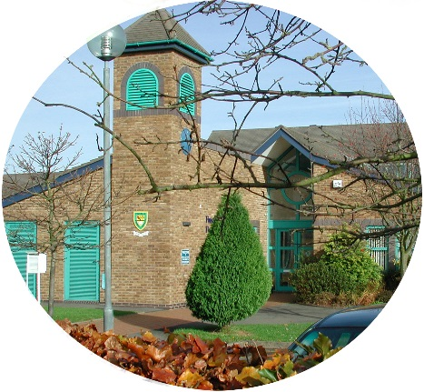
FINSTALL FIRST SCHOOL
Carnforth Road
BROMSGROVE
Worcestershire
B60 2HS
Tel: 01527 872938
E-mail office@finstallfirst.co.uk
Web Site www.finstallfirst.co.uk

HEADTEACHER: Mr Stuart Evans
Learning Together, Preparing for Life

5th March 2021
Dear Parents,
Return to School – Monday 8th March

Further to my letter of 23rd February, I write to remind parents of the routines that will be in place to help keep everybody as safe as possible when the children return to School.

- Collection and drop-off times will be staggered and, to further minimise contact at these times, we will be operating a “fluid” one-way system around the School.
- Please keep to your allocated drop-off and collection windows and ensure that you do not arrive on the School site before your window opens. If you do arrive before the classroom door is opened, please
do not start to queue, please follow the one-way system around the School, across the playground and return through the front of School so that you can arrive once the classroom door has opened.
- Please could all adults wear face masks at all times when on the School premises.
- Please do your best to keep 2 metres apart at all times and do not congregate in groups.
- Please keep your children by your side at all times, whilst on the School site.
- Please ensure that only one adult collects or drops off (this does not always have to be the same adult).
- At hand-overs, please keep 2 metres away from staff.

Collection and drop-off times are as follows:

Class | Drop-off window | Collection window
Rabbits | 9.00 – 9.10am | 2.55 – 3.05pm
Hedgehogs | 9.10 – 9.20am | 3.05 – 3.15pm
Kingfishers | 9.00 – 9.10am | 2.55 – 3.05pm
Woodpeckers | 8.50 – 9.00am | 2.45 - 2.55pm
Owls | 8.50 – 9.00am | 2.45 - 2.55pm
Kestrels | 9.10 – 9.20am | 3.05 – 3.15pm
Otters | 9.00 – 9.10am | 2.55 – 3.05pm
Squirrels | 8.50 – 9.00am | 2.45 - 2.55pm
Foxes | 9.05 – 9.15am | 3.00 – 3.10pm
Badgers | 9.10 – 9.20am | 3.05 – 3.15pm

Asymptomatic testing information for parents of School age children

For a number of weeks now, the staff in School have been undertaking regular, rapid coronavirus (COVID-19) testing, using lateral flow tests. With one in three people who have coronavirus being asymptomatic, this helps to reduce transmission of the virus. This regular testing, which is self-administered at home, is now being made available to parents of children of Primary School age (and below). Please see overleaf for more information.
PTO

Communication / Uniform

To avoid prolonged contact between parents and staff at hand-overs, please keep verbal messages concise and to a minimum. We will be reinstating the system of Communication books, which will be kept within each class’s “Bubble.” The class and “pod” e-mail systems will be closed down at the end of the day on Friday 5th March.
Please do your best to send children back to School in uniform.

School Office

Please only attend the School Office in person if it is absolutely essential. You can still contact the office by phone or e-mail.

Asymptomatic testing information for parents and adults in households with children at school or college

NHS Test and Trace announced earlier this week, that all adults in households with school and college age children without symptoms can now access regular rapid coronavirus (COVID-19) testing. This includes childcare and support bubbles. Undertaking regular, rapid coronavirus (COVID-19) testing helps reduce transmission of the virus.

Test kits are fast, easy and completely free and can either be collected or ordered online, as set out below.

There are different ways for a household, childcare or support bubble to collect their test to take at home, twice-weekly:
- through your employer, if they offer testing to employees
- by collecting a home test kit from a local test site – anyone aged 18 or over can collect
2 packs of 7 tests
- by ordering a home test kit online – please do not order online if you can access testing
through other routes, this frees up home delivery for those who need it most
If you want to collect a test kit from a local test site, you do not need to make an appointment. Most collection points are open from 1.30pm to 7pm. You can check online if the location is open or busy before you go.
Do not visit a collection point outside opening hours, as it may be used to test people with coronavirus symptoms outside these times. To find your nearest home test kit collection point, please use the link below:

https://find-covid-19-rapid-test-sites.maps.test-and-trace.nhs.uk/

If you have any queries about the tests, and you live in England, please call 119 (free from mobiles and landlines). Lines are open every day from 7am to 11pm.

Children of primary school age (and below) without symptoms are not being asked to take a test.

Testing is voluntary, but strongly recommended to all who are eligible. Alongside the vaccine, washing hands, wearing face coverings, and maintaining social distancing, rapid testing plays a vital role in reducing transmission rates.

Getting into the habit of regular testing as part of our everyday lives will help us all to play our part and do what we can to protect each other.

Thank you again for your continued support. We are really looking forward to welcoming all of the children back into School on Monday 8th March.

Yours sincerely,

Stuart Evans
Head Teacher

